

| Business Template  **EC2** |
| --- |
|  |

**Notice:** I uploaded this file to my S3 bucket, along with a ZIP archive named **credentials**, which contains my key file, the JSON instance description, and the CloudFormation script used for the final configuration.

1. The cheapest way of creating a database in Cloud - take just a virtual machine (EC2 in our case) and install database by your own. Let’s do it.

a. Create EC2 t2.micro instance (EBS volume size should be not more than 10GB and security group should be “dilab-training”) and add **AWS_EC2_full_access_S3** role to it to allow S3 access for your EC2 machine. Name of the instance as always should be **recognizable**. As an **Important** security requirement ensure that *Metadata Service Version 2* is enabled: on *Launch an instance*page click *Advanced details* and ensure that *Metadata accessible* is set to Enabled and *Metadata version* set to V2 only.

**NOTE:** Use any suitable free distributions of Linux as OS in the EC2 VM.

**NOTE:** In the lecture you saw creation of 128GB disks for EC2, it is just an example for you to understand that EC2 instance could have root volume and mounted volumes, no need to create same big volumes, one 8GB root volume and one 10GB mounted volume will be enough.

Here, I created the instance called **ec_2_postgresql_server_gabriela_cretu**, ensuring that all the requirements were met-verything starting from the instances tab in cloud and then “Launch an instance”. I used the security group **dilab_training_new** instead of the **dilab_training** security group. As requested, I created a root volume of **8 GB** and a mounted volume of **10 GB**, as shown in the picture. Additionally, while the video used **t2.micro**, I opted for **t3.micro** this time, as cloud setups generally prioritize free-tier options, and **t3.micro** was the free-tier instance type available.

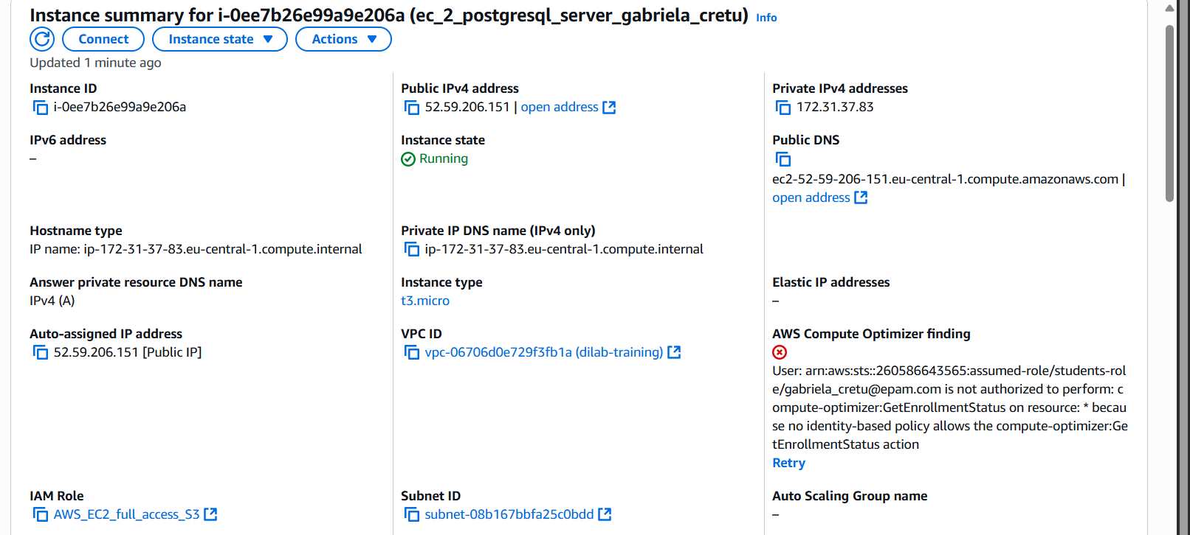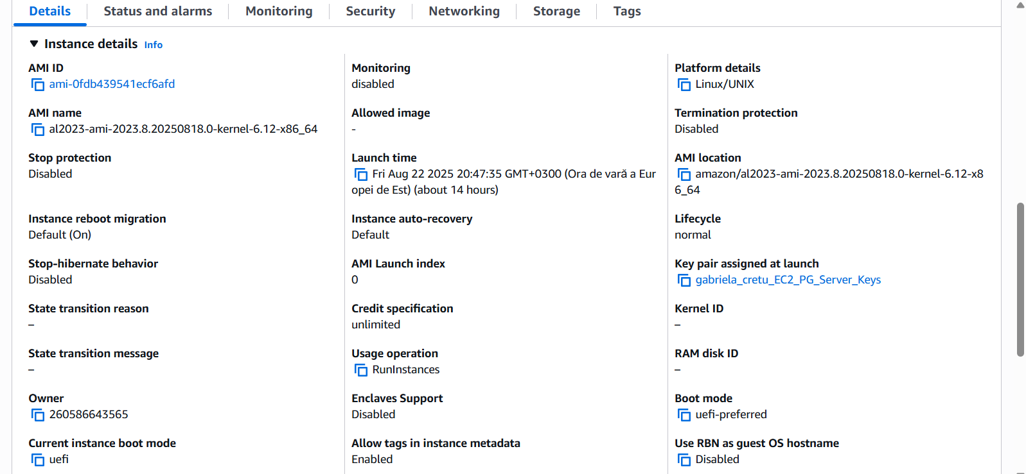

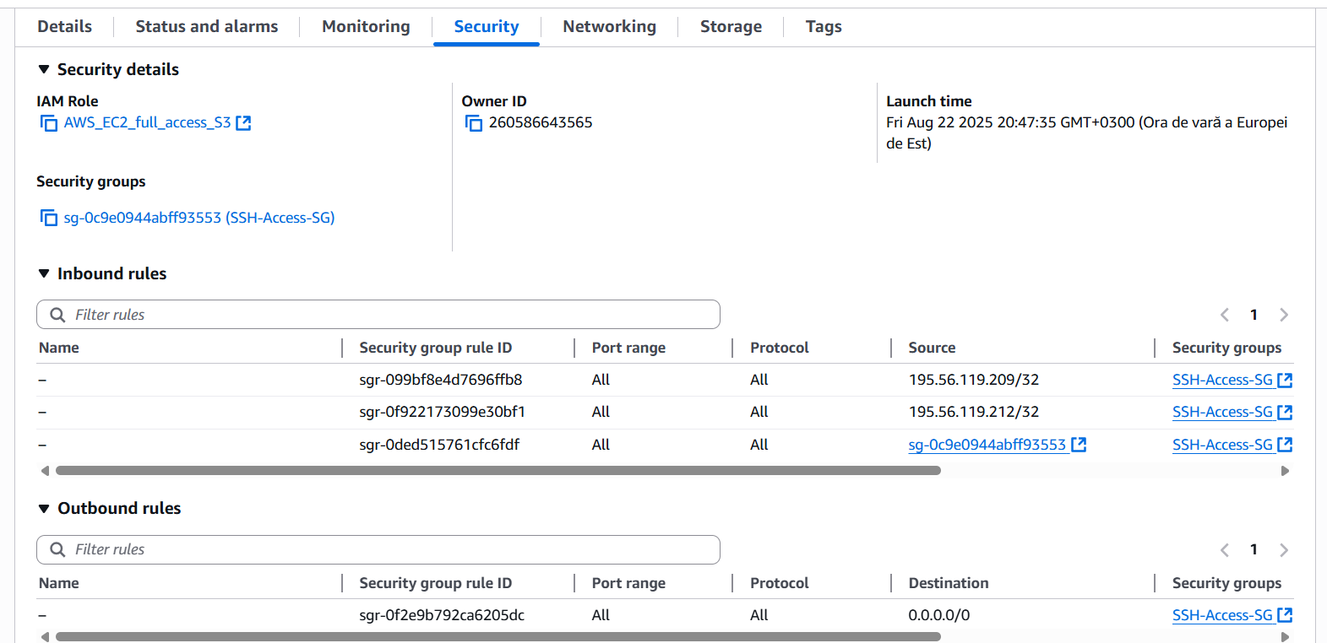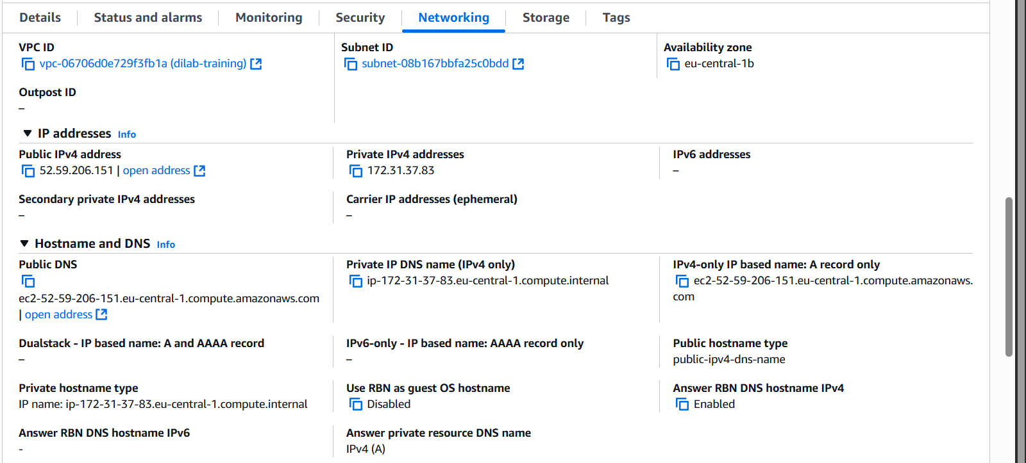

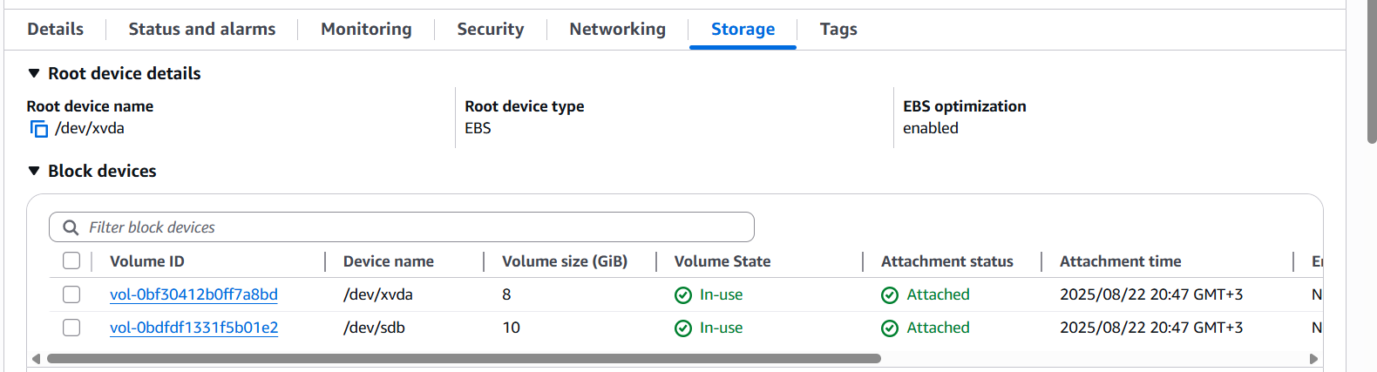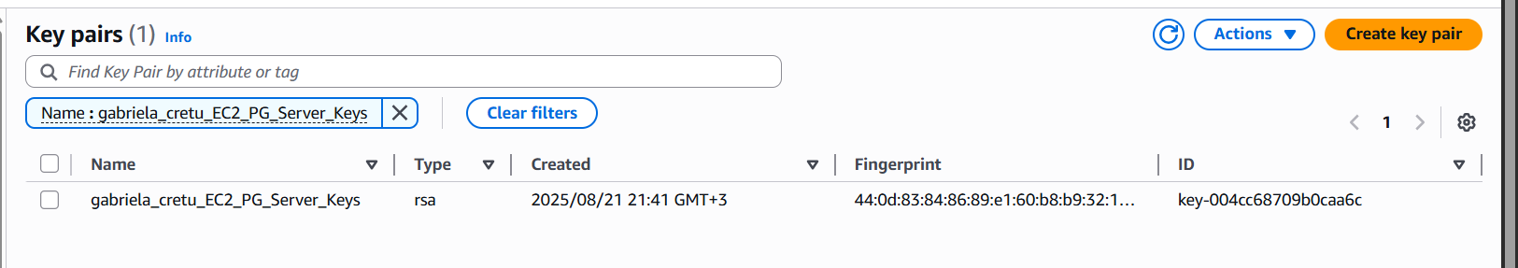

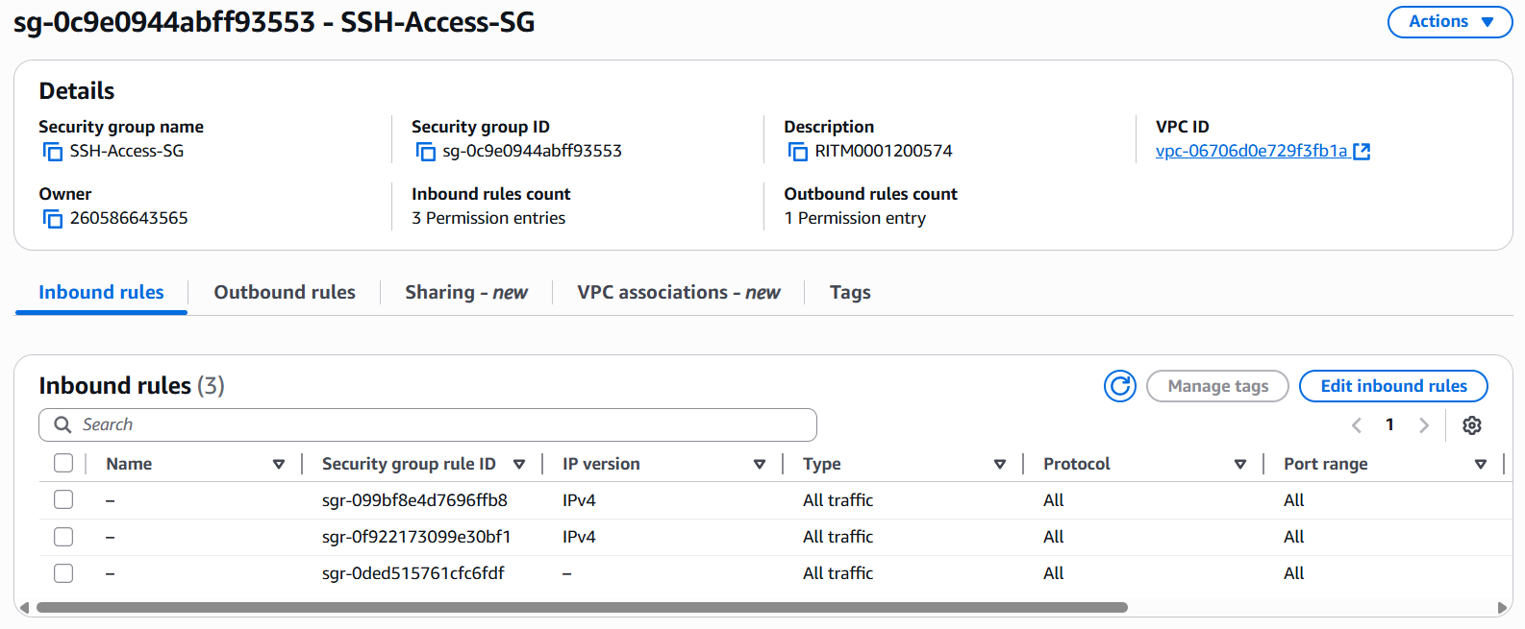

b. Install Oracle/ or PostgreSQL/ or MySQL on the EC2.

**NOTE:** If OS picked in a. is Linux, use the command line to perform the installation.

In the first place as in the video I tried to use the connect option of instances, but it did not work, so after failed attempts I opted for the Windows Powershell command line. In order to install postgres we simply used the command sudo dnf instll postgresql15-server-y.

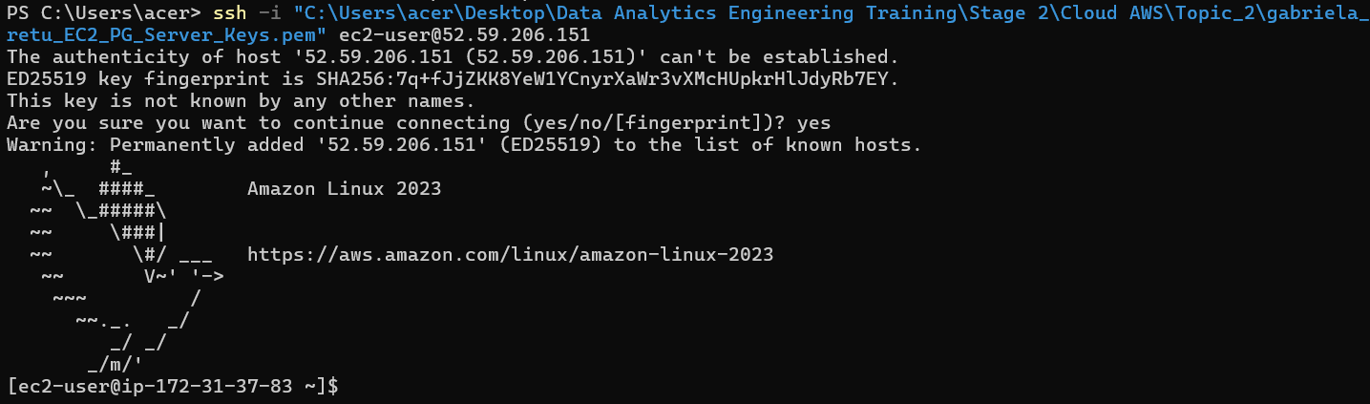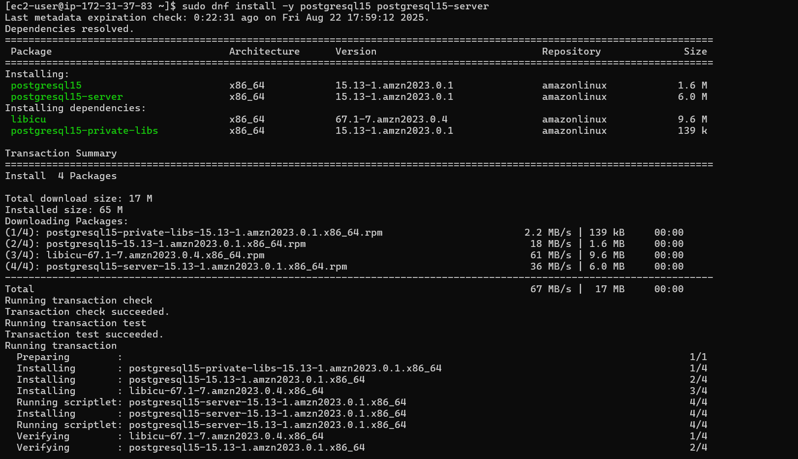

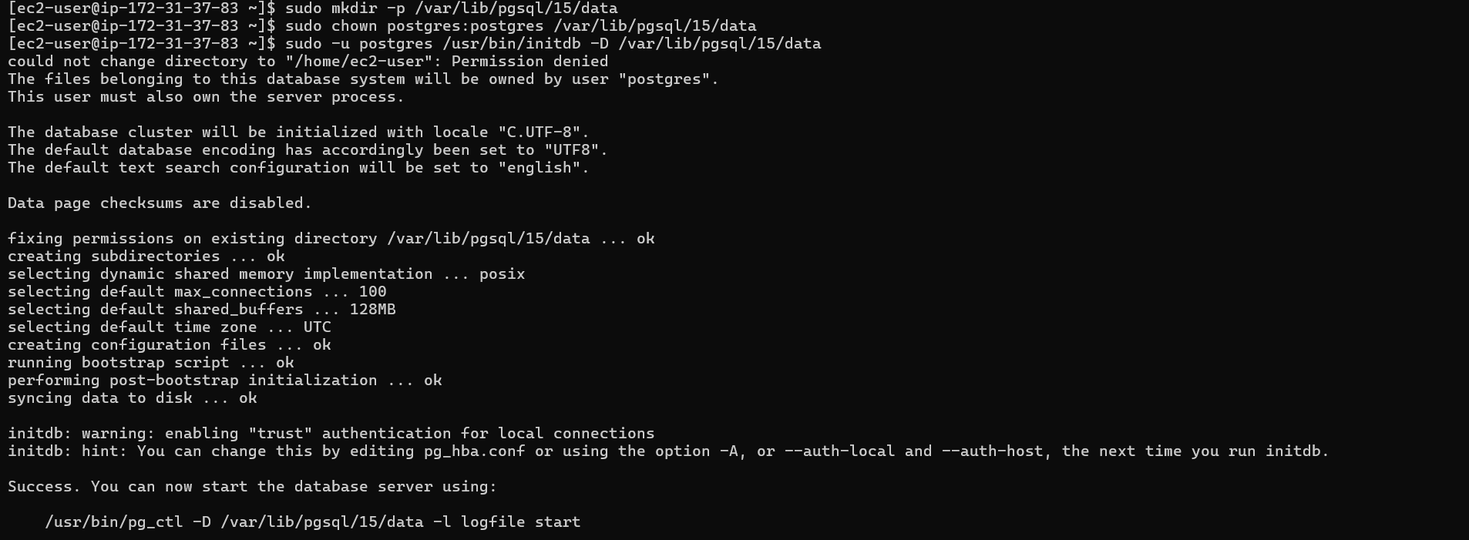

c. Connect to this database from any SQL client (e.g. DBeaver - very useful IDE because of community edition and possibility to work with almost all most famous databases).

d. Insert your connection configuration (host, database, user, password) for mentors to check the connectivity, screens that you have connected to the db on your EC2 into the Report.

We will connect to my PostgreSQL database hosted on an Amazon Linux EC2 instance using **SSH tunneling**. Please follow these steps:

**1. Prerequisites**

* Install **DBeaver** (Community Edition is fine).
* Ensure you have the private key file:  
   gabriela_cretu_EC2_PG_Server_Keys.pem

**2. Start the SSH Tunnel (PowerShell)**

Before opening DBeaver, run this command in **Windows PowerShell** to create the tunnel:

*ssh -i "C:\Users\acer\Desktop\Data Analytics Engineering Training\Stage 2\Cloud AWS\Topic_2\gabriela_cretu_EC2_PG_Server_Keys.pem" -L 5432:localhost:5432 ec2-user@52.59.206.151*

* This forwards **local port 5432** to the PostgreSQL server running on the EC2 instance.
* Keep this PowerShell session open while you are connected to the database.

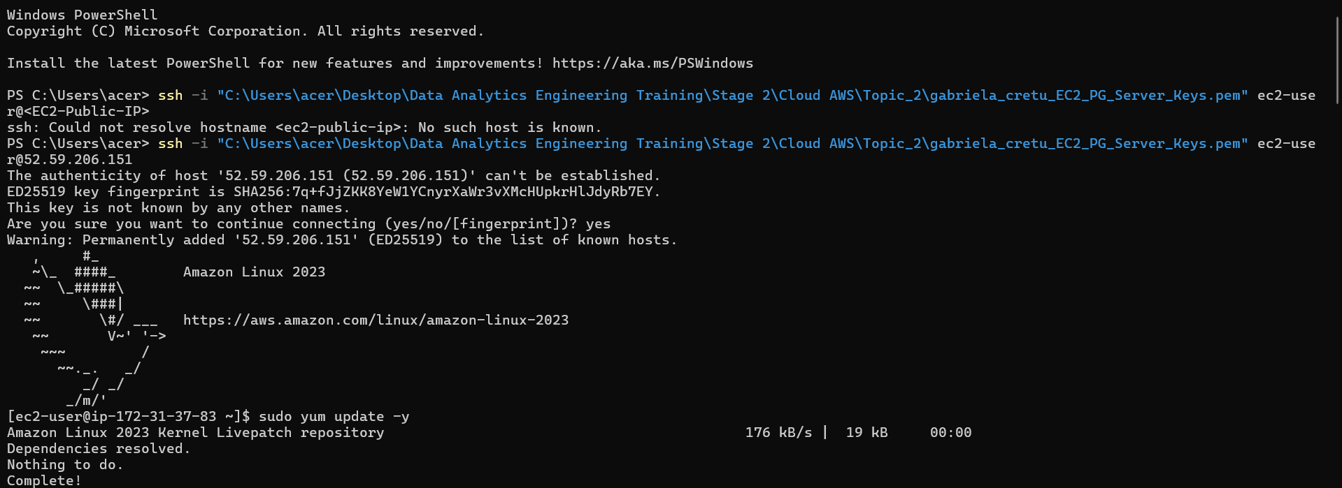

## **3. PostgreSQL Connection Details (DBeaver)**

| **Parameter** | **Value** |
| --- | --- |
| Database Host | localhost |
| Database Port | 5432 |
| Database Name | postgres |
| Database Username | postgres |
| Database Password | CretuPaul1990. |

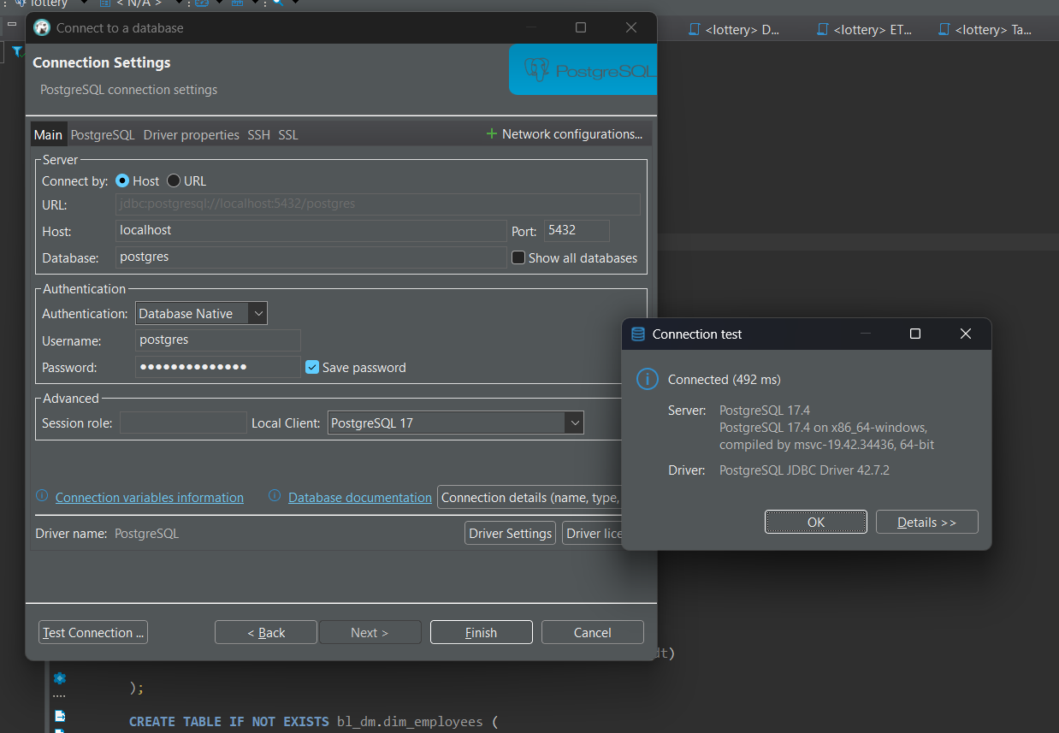

## **4. SSH Tunnel Configuration in DBeaver**

If you prefer, you can also set up the tunnel directly in DBeaver:

* **Enable SSH Tunnel**
* **SSH Host/IP:** 52.59.206.151
* **SSH Port:** 22
* **SSH Username:** ec2-user
* **Authentication Method:** Public Key
* **Private Key:** Use the .pem file

This achieves the same effect as the PowerShell command.

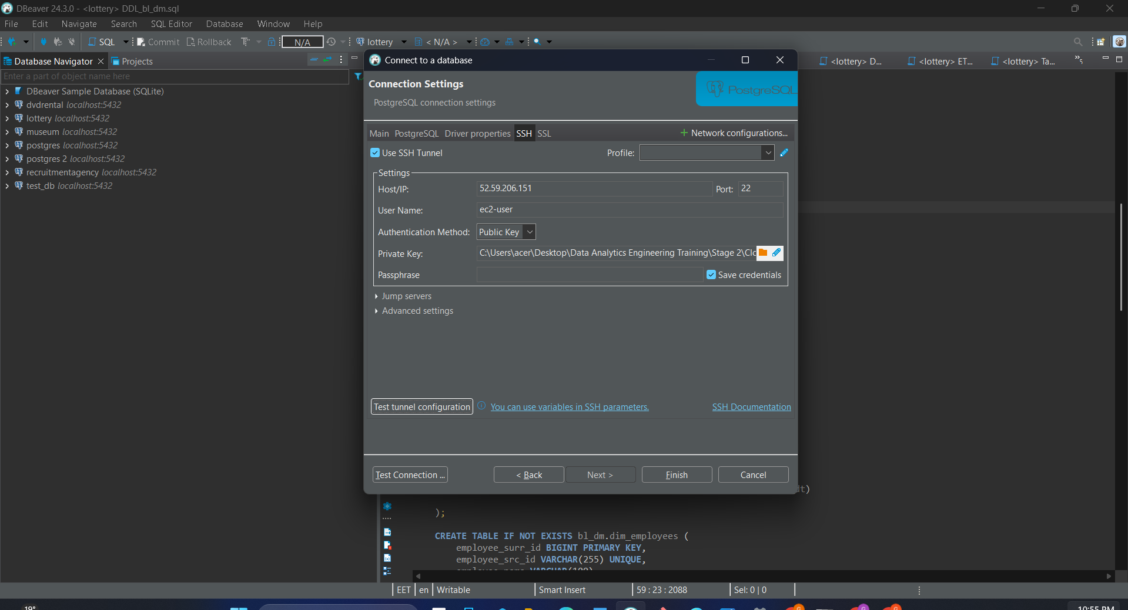

## **5. Testing the Connection**

1. Click **Test Tunnel Configuration** → it should show **Success**.
2. Click **Test Connection** on the main tab → it should connect to PostgreSQL.

If both tests are successful, you can now interact with the database using DBeaver.

## e. Create several objects in the created database ( at least one table, view, procedure ).

I have created the following sample objects:

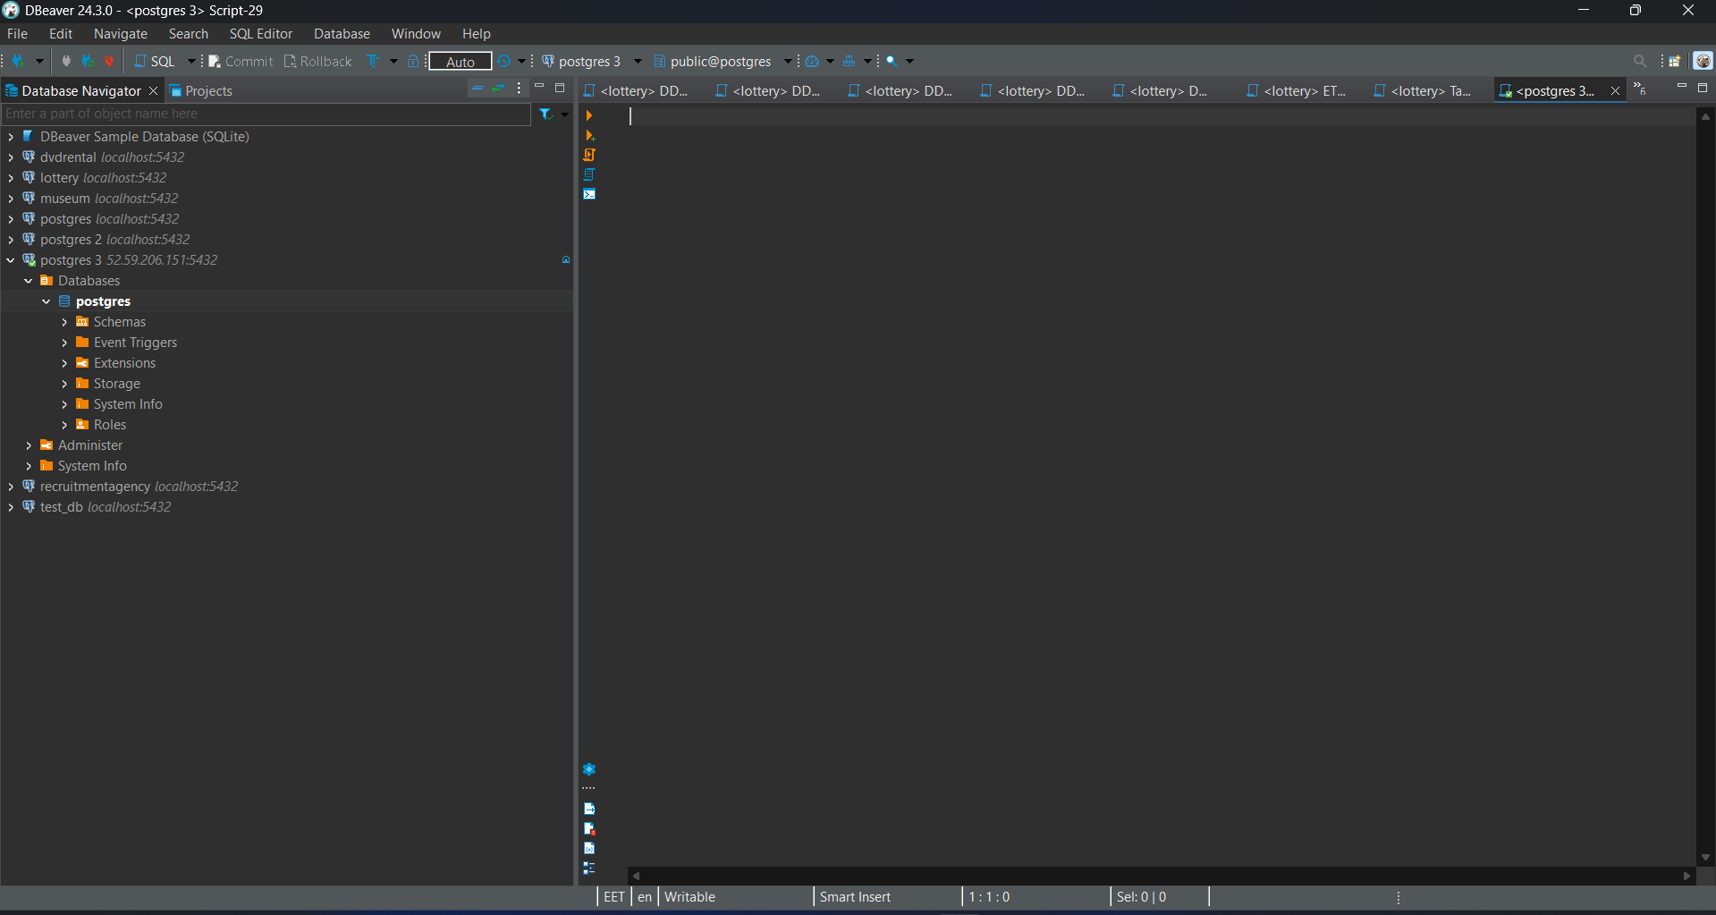

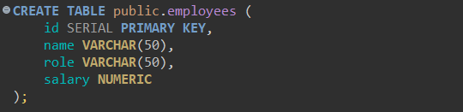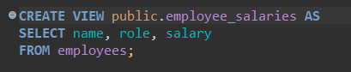

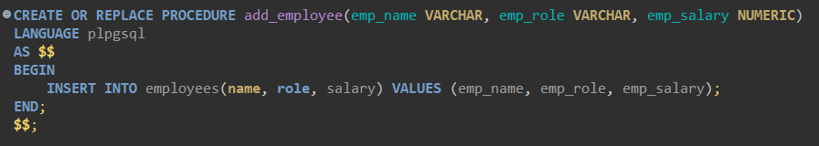

***Important Notes***

* Keep the **SSH tunnel session in PowerShell active** while using the database.
* You do **not** need to install PostgreSQL locally — the connection goes directly to the EC2 instance.
* Use localhost:5432 as the host in DBeaver because traffic is forwarded through the SSH tunnel.

2. Take any file from your S3 bucket and copy it into the EC2 using **AWS_EC2_full_access_S3** role that has been attached to the virtual machine on the first step. Screen of the files inside the EC2 into the Report.

First, we re-logged into our user role and listed the available files. As we previously created a test file in our S3 bucket during the earlier task, we will now copy this file to the EC2 instance. The role attached to our EC2 instance (**AWS_EC2_Full_Access_S3**) allows the instance to access and copy files from S3, so we can perform this operation without manually handling credentials.

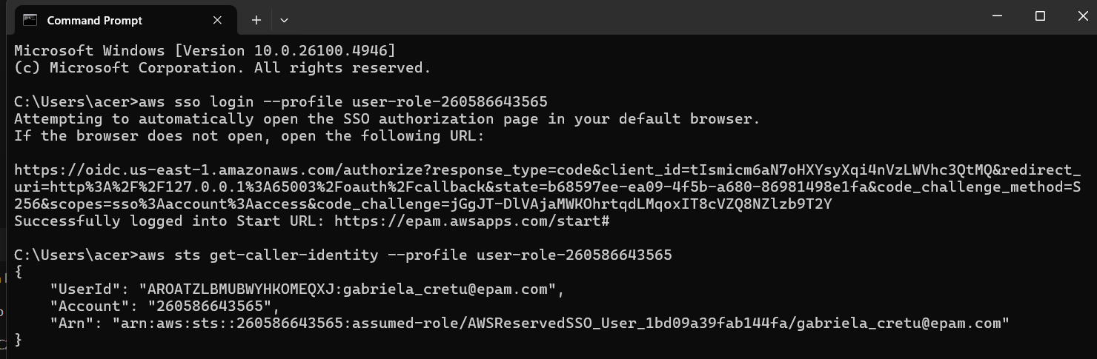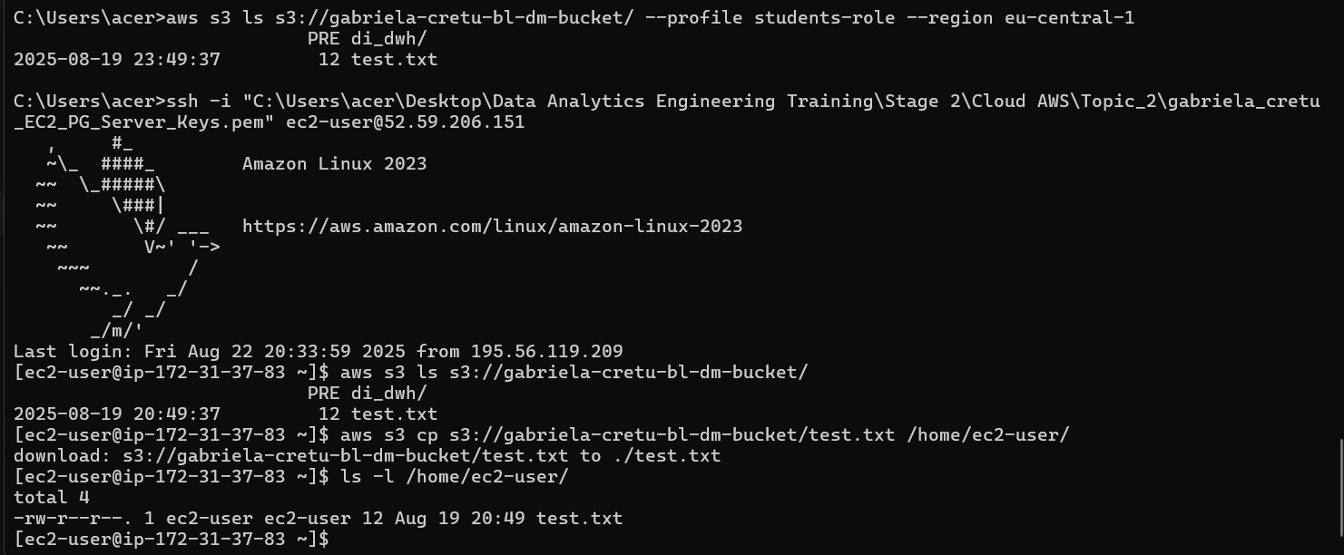

3. For you EC2 a separate EBS volume was allocated. Let’s create snapshot of this EBS volume. Afterwards, let’s create AMI **(identifiable name)** from the created previously snapshot. It will be a copy (image) of your EC2 machine.

### 🔹 Step 1: Identify your EBS volumes We logged in to the AWS Console → EC2 service. In the left menu, we went to Volumes. We found the EBS volumes(the root and mounted volumes) that are attached to our EC2 instance (check Instance ID column).

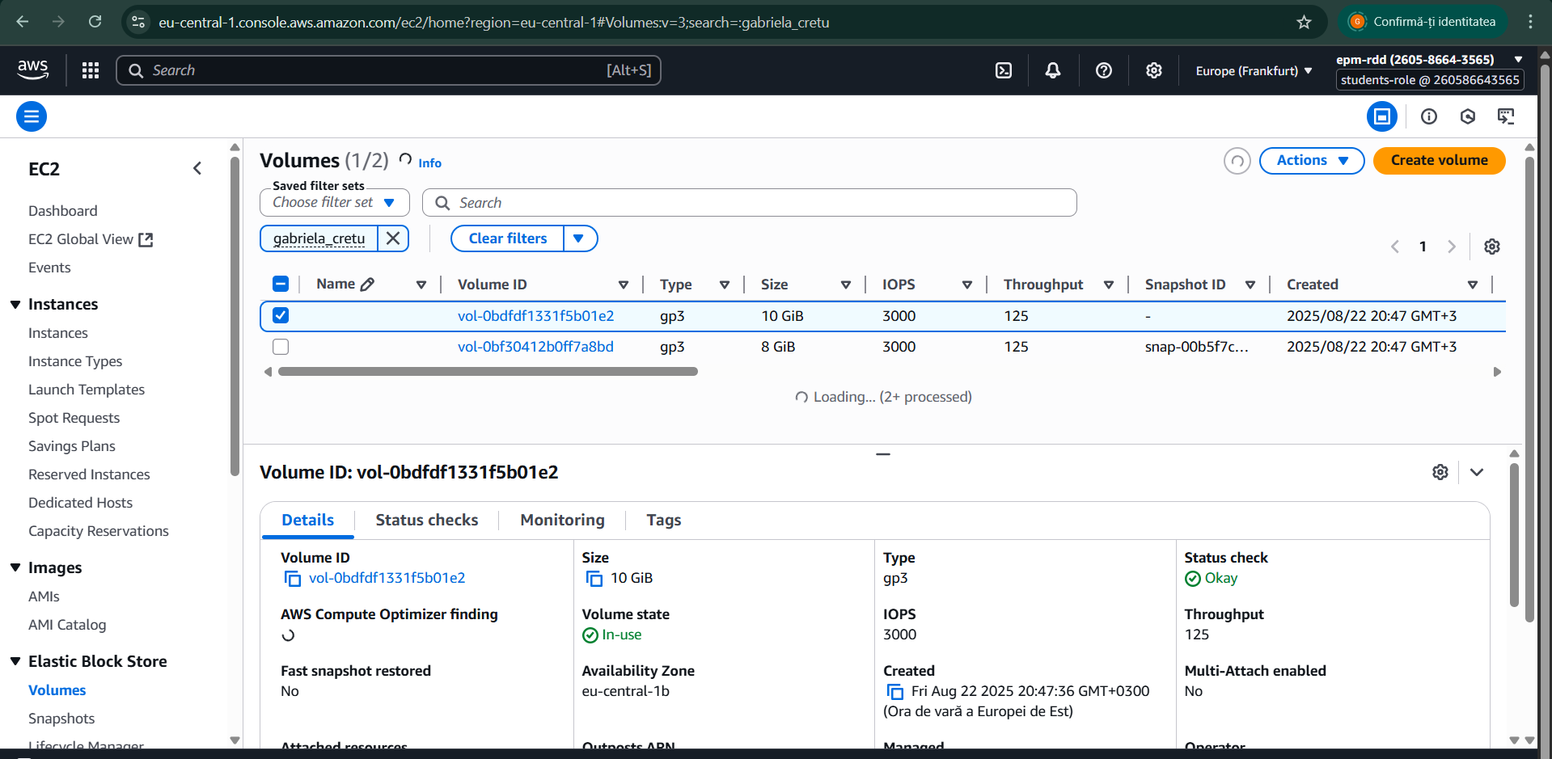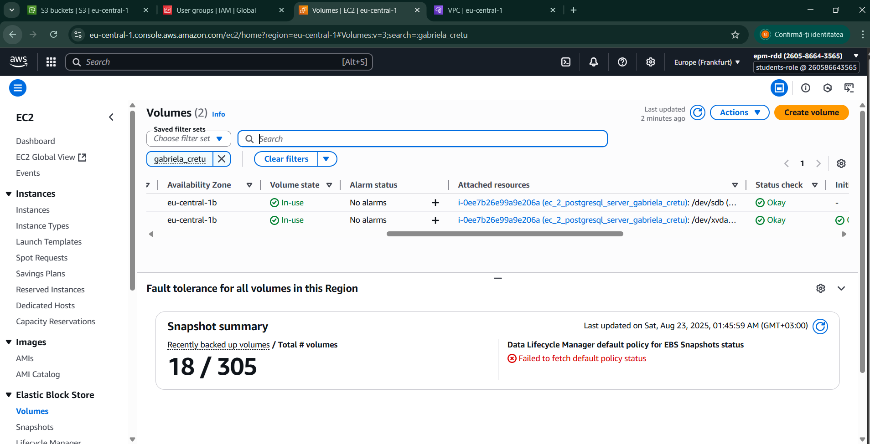

### 🔹 Step 2: Create a Snapshot We selected each volume and created a snapshot for each, which we will later use in our AMI. Specifically, we chose Create snapshot and named them as follows: ec2_gabriela_cretu_8gb_volume for the root volume and ec2_gabriela_cretu_10gb_volume for the mounted volume. We then waited until both snapshots reached the “completed” status.

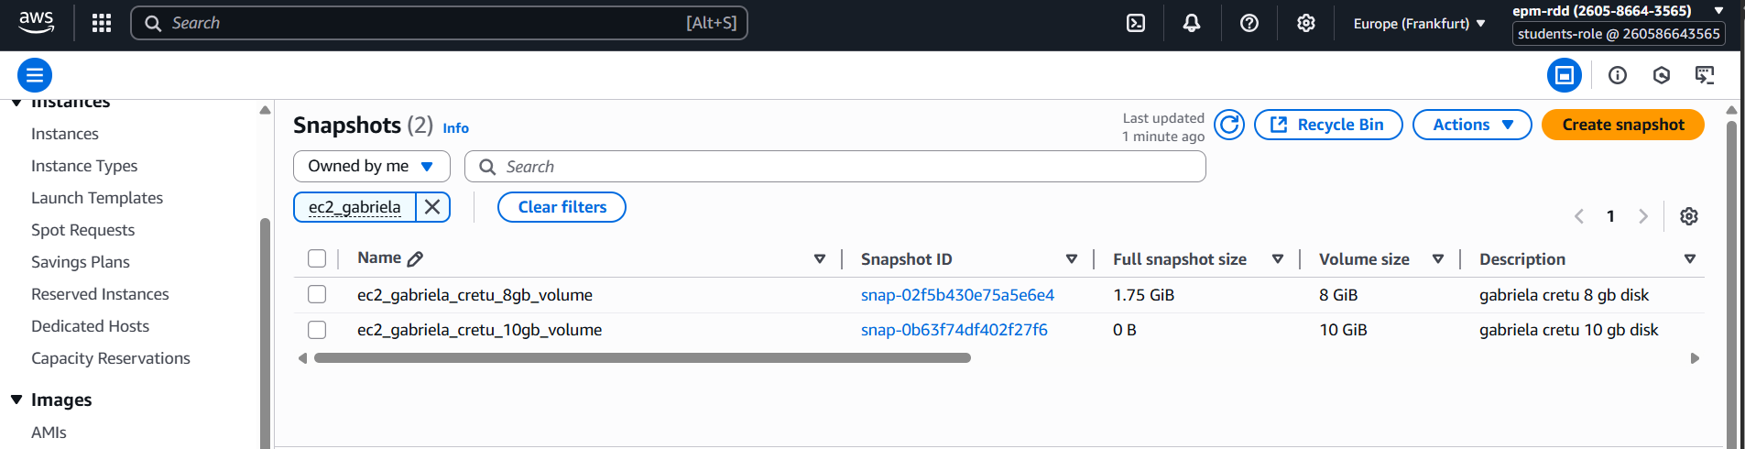  
.  
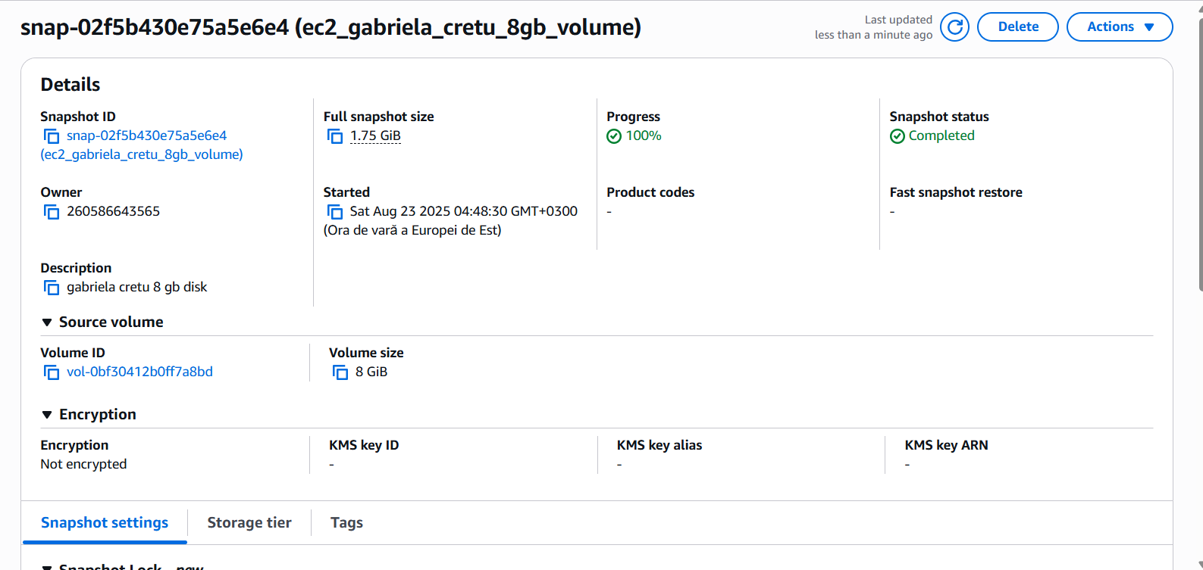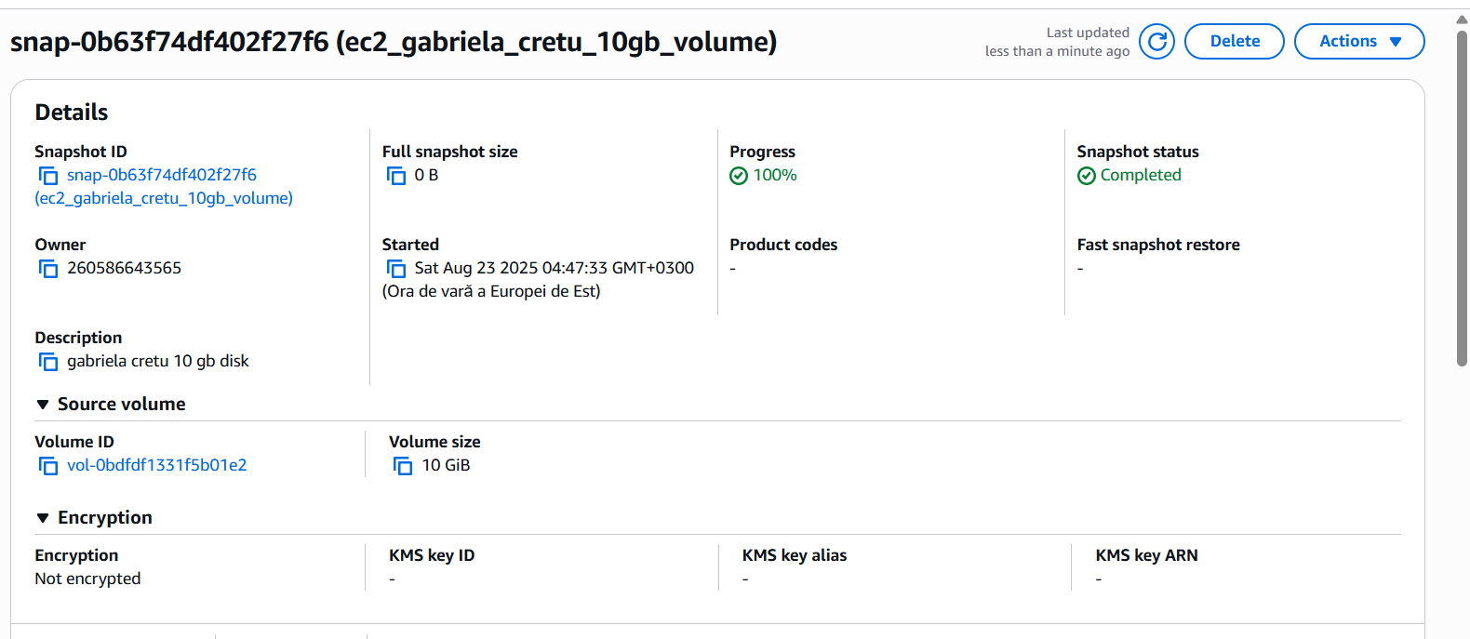

### 🔹 Step 3: Create AMI from Snapshot I navigated to Snapshots in the EC2 menu. Using the snapshots, we created an AMI (Amazon Machine Image). To do this, we first selected the root snapshot and chose Create image from snapshot. Then, we added an additional volume and attached the second snapshot for the mounted volume. Finally, we assigned a representative name: ec2_gabriela_cretu_AMI.

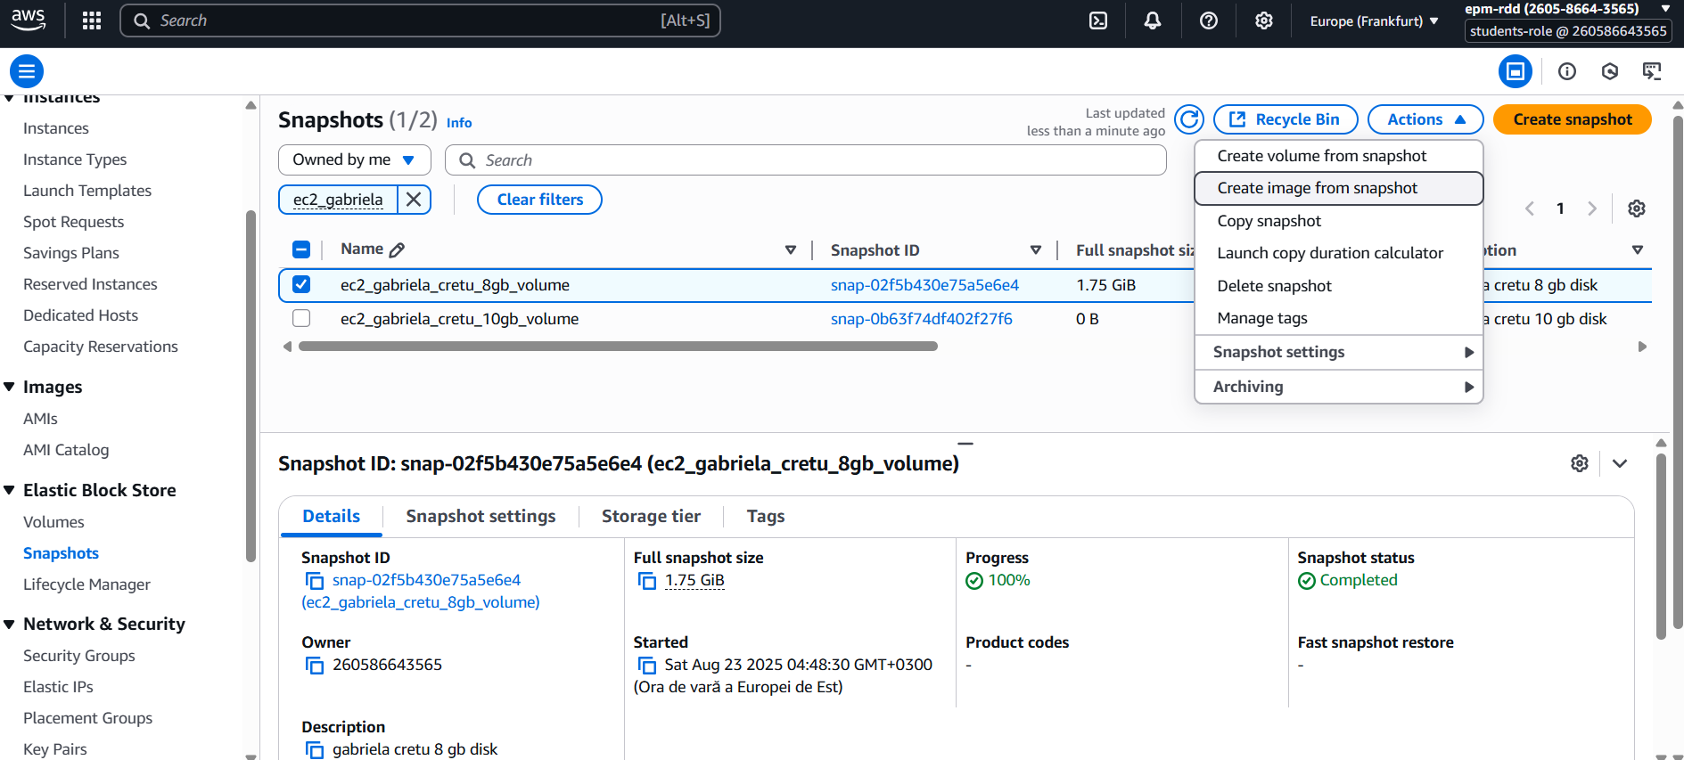

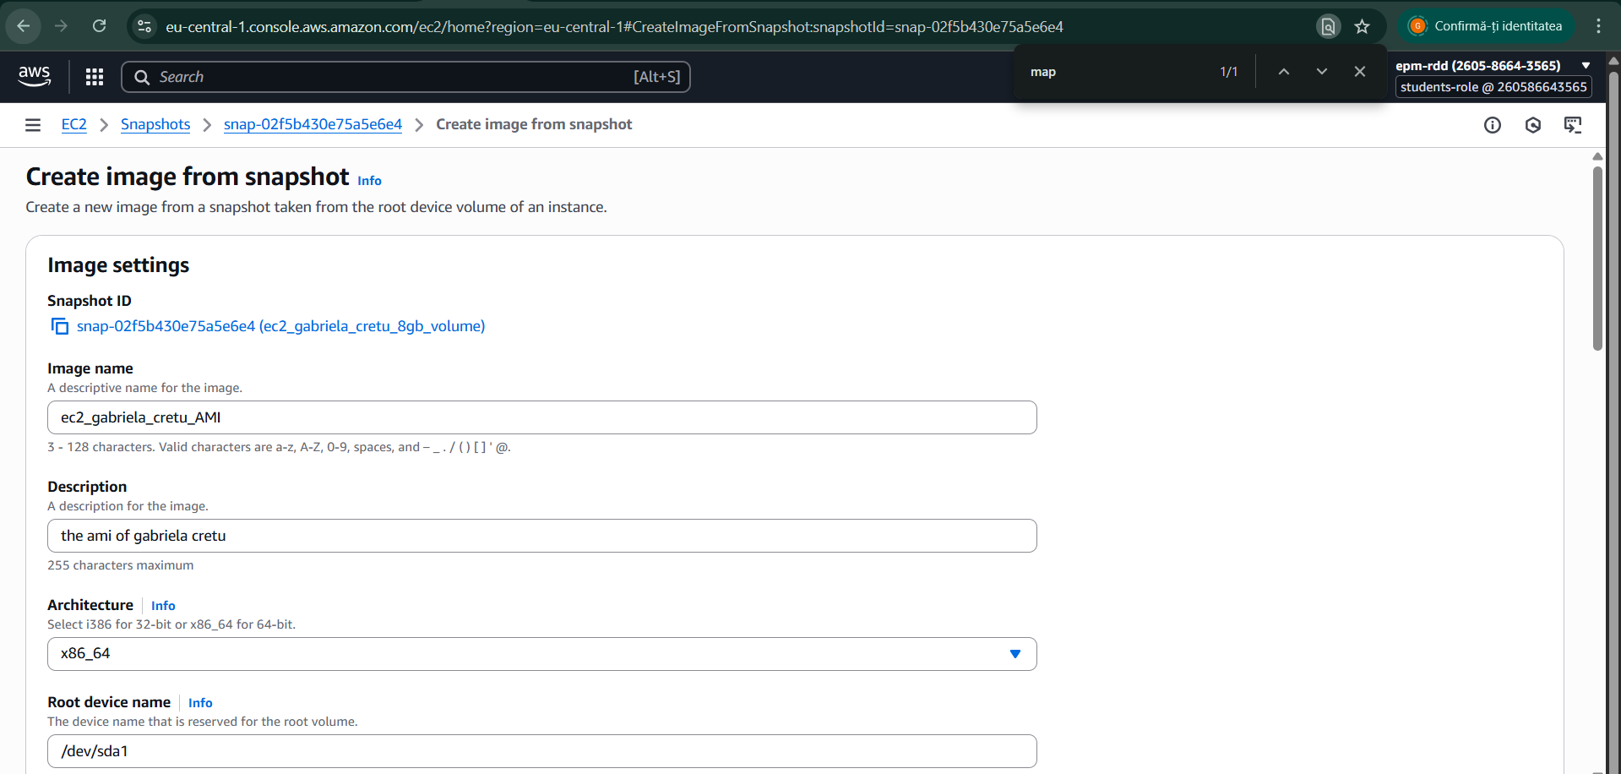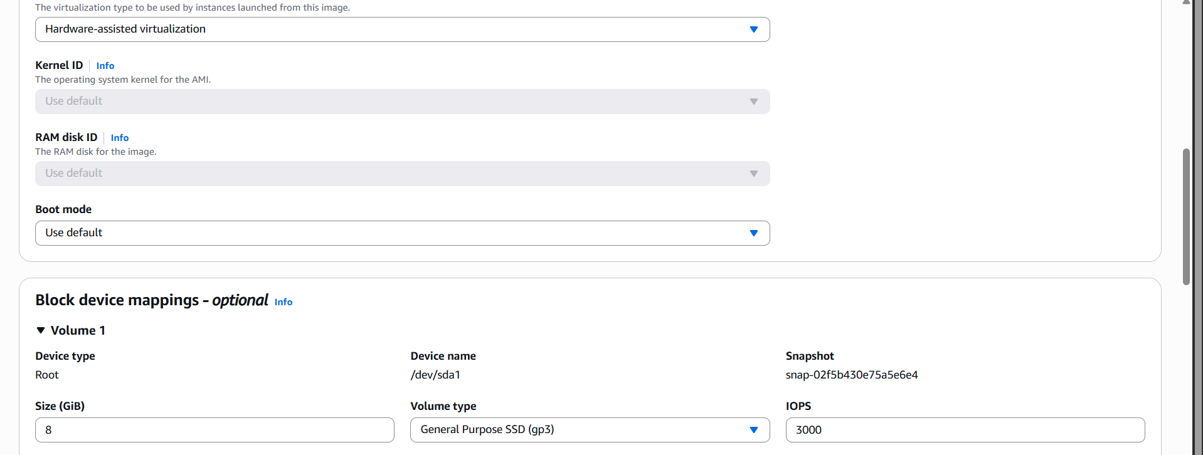

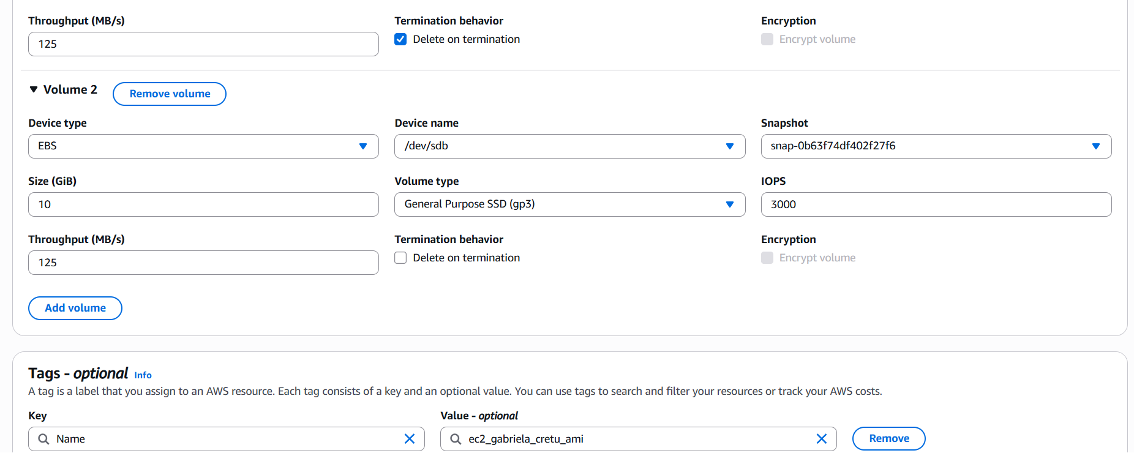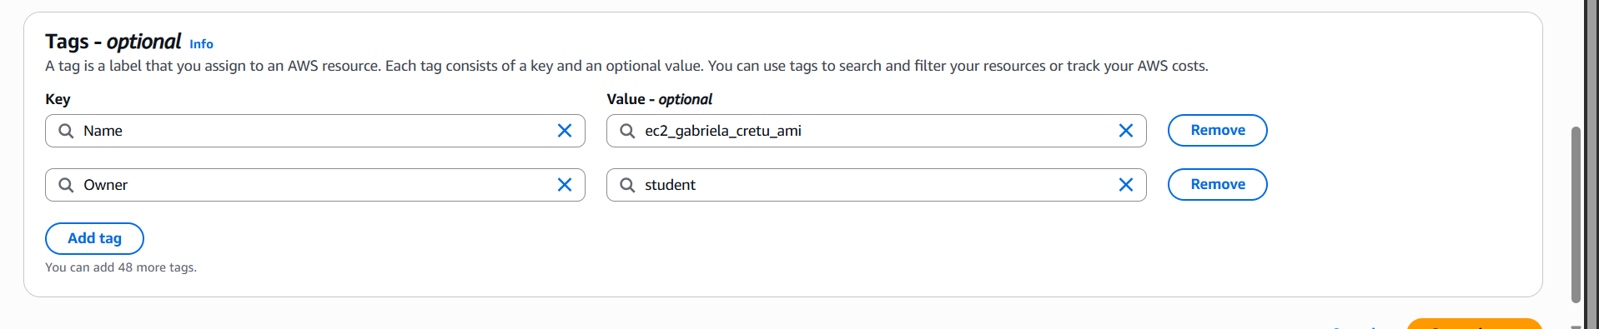

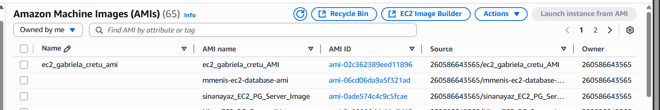

4. From the image (AMI) you've made on the step 3, raise a copy of the EC2. As an **Important** security requirement ensure that *Metadata Service Version 2* is enabled: on *Launch an instance*page click *Advanced details* and ensure that *Metadata accessible* is set to Enabled and *Metadata version* set to V2 only.

Show that the data file you put to the EC2 on the step 2 has been saved into the server copy as well. Save the screen into your Report.

### 🔹 Step 4: Launch an Instance from the AMI We went to the AMIs page in the AWS Console → EC2 → Images → AMIs. We located the AMI we had just created (ec2_gabriela_cretu_AMI) and selected *Launch instance from AMI.* For the instance type, we chose the same type as the original EC2 instance . In the Advanced Details section, we configured: Metadata accessible → Enabled and Metadata version → V2 only. These settings ensure compliance with the required security standards.

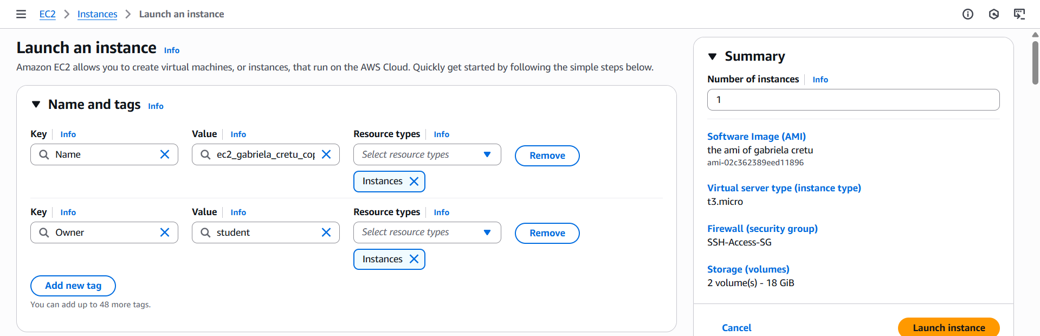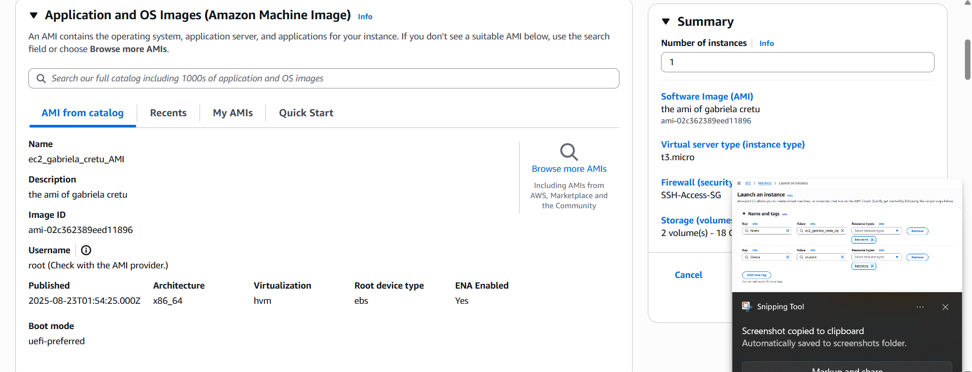

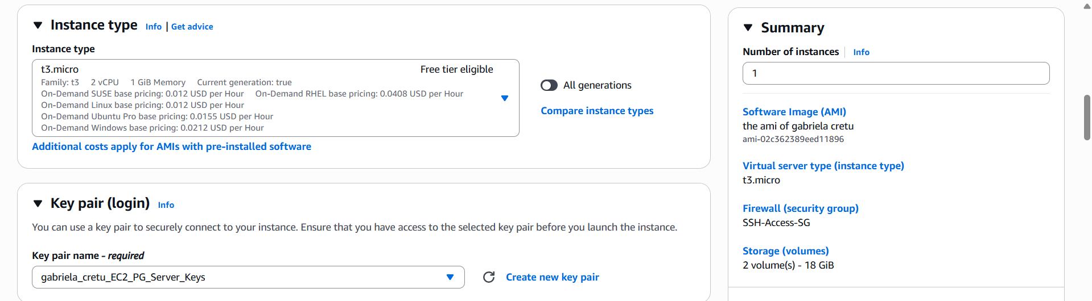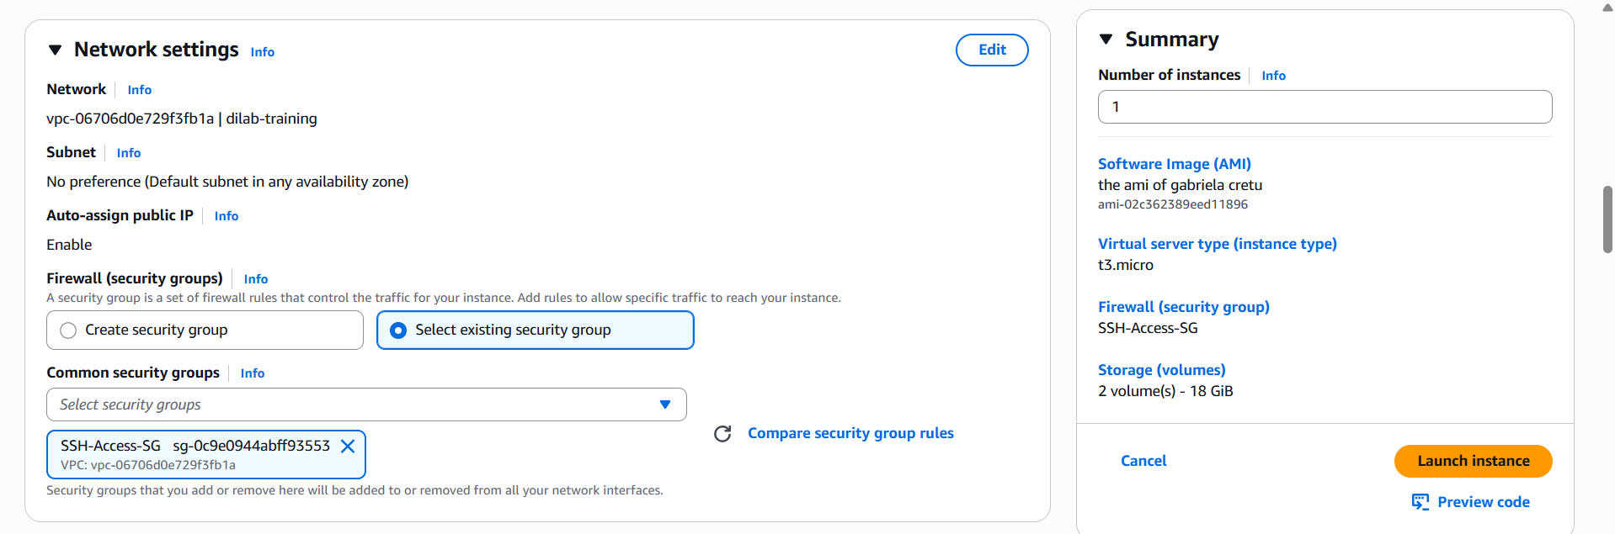

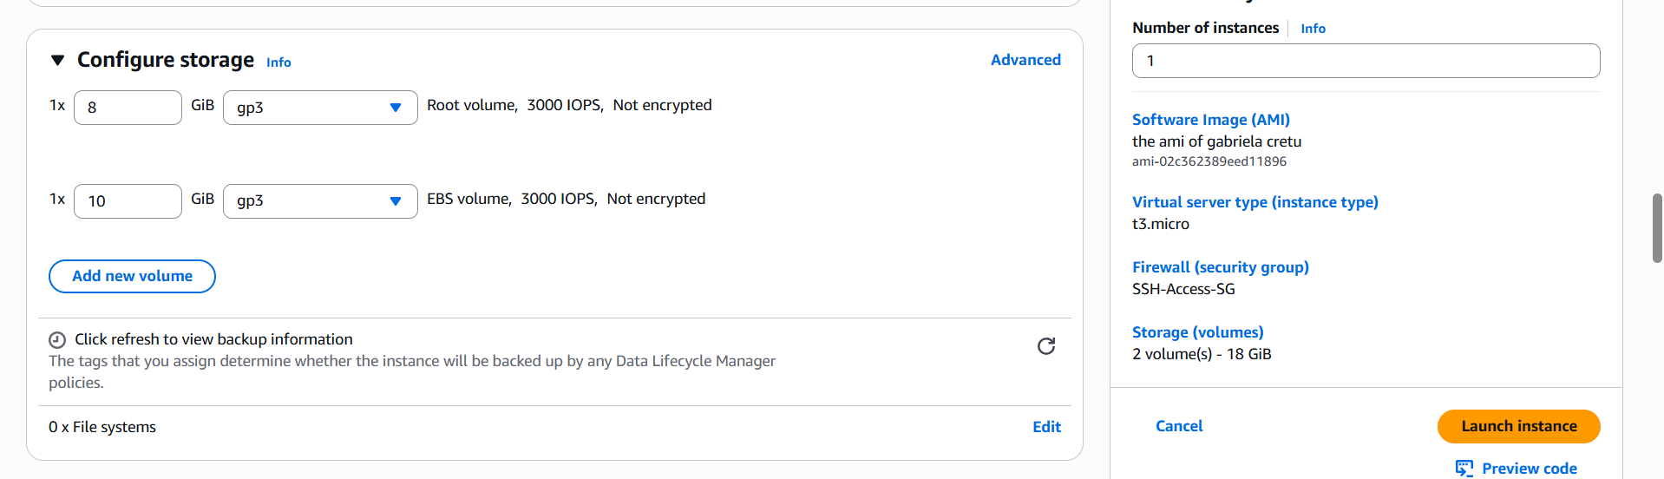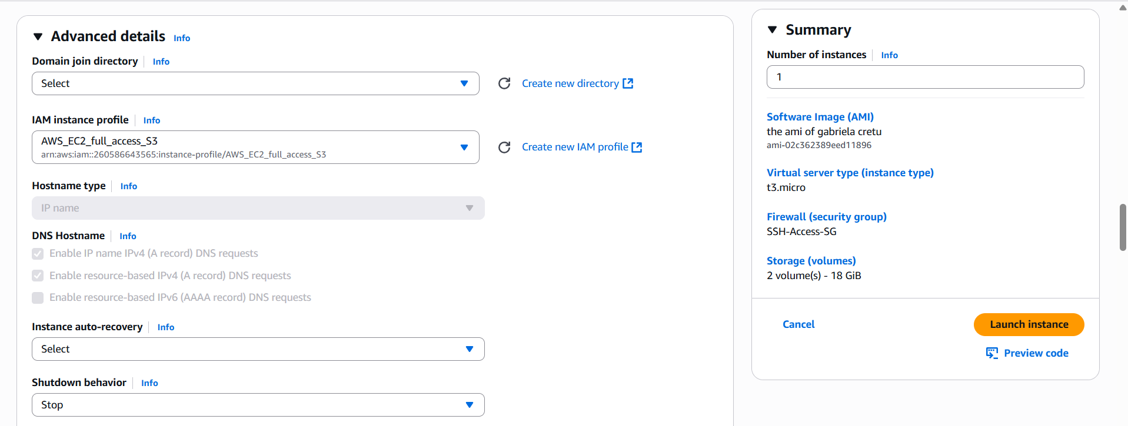

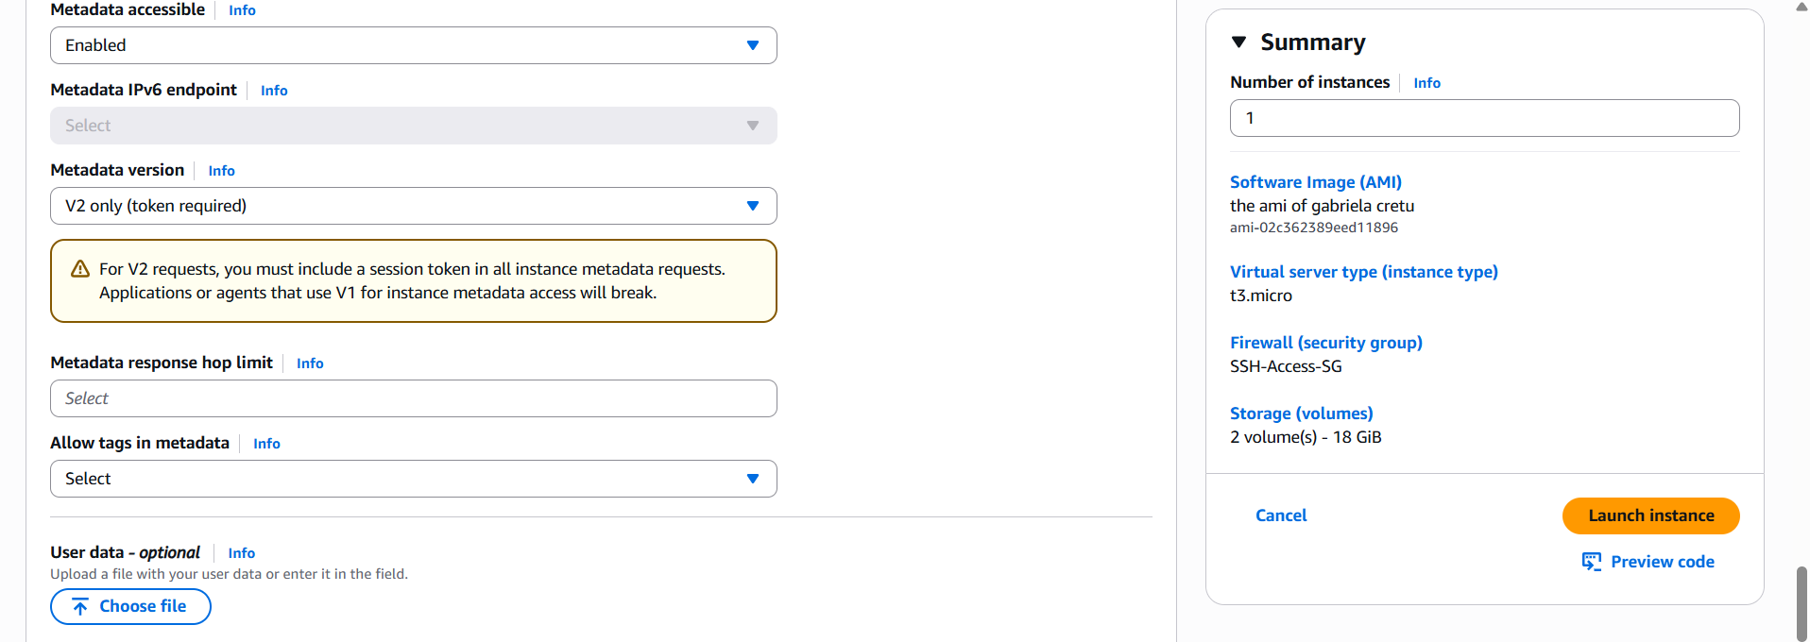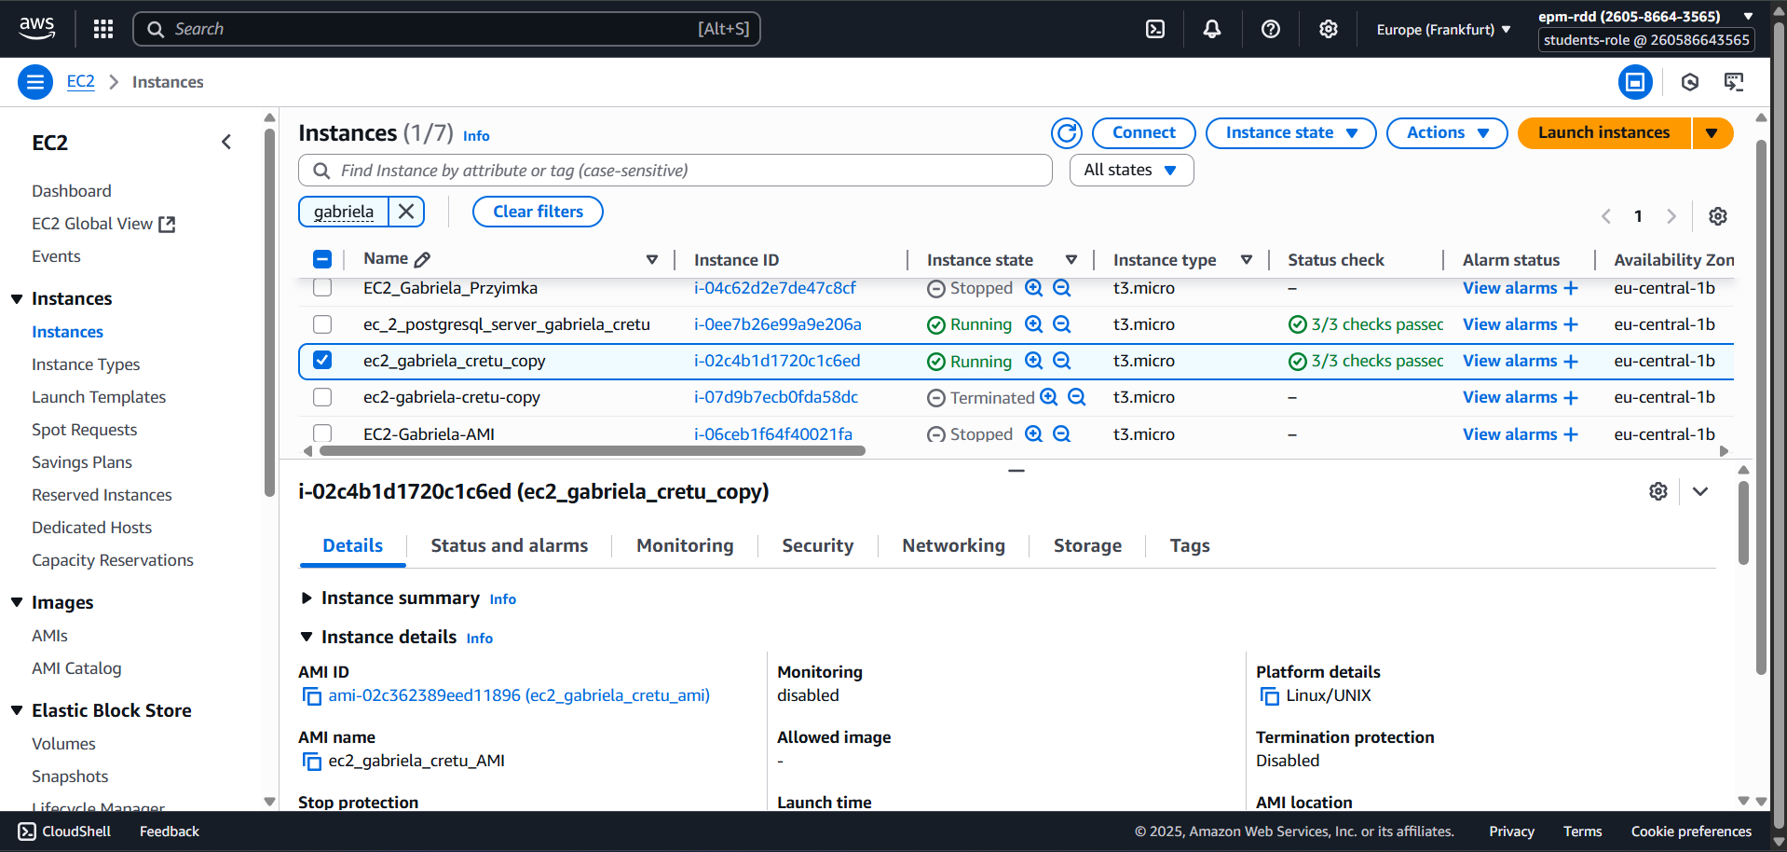

🔹 **Step 5: Verify Your Data** We connected to the new EC2 instance via SSH: (<new-public-ip>= 54.93.248.41) ssh-i"your-key.pem"ec2-user@<new-public-ip>. Once inside, we checked if the test file from **Step 2** was present: ls /home/ec2-user/.

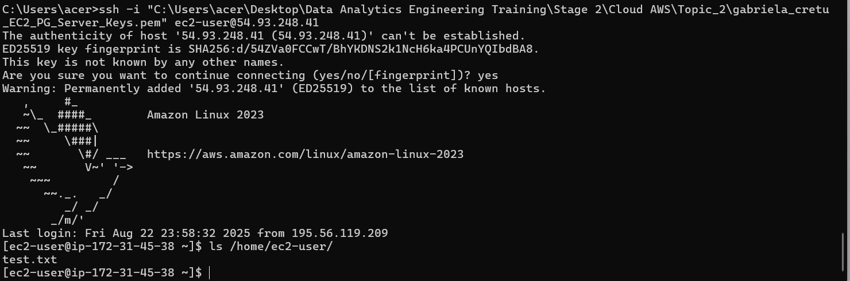

5. Create your first web page, install apache web server and push any html to the standard directory /var/www/html (apache web server installation and html example will be in the general folder).

Check that the page is available by IP address from the browser and insert link to this page and screens into the Report. Using link mentors should have a possibility to see your web page.

🔹 **Step 1: Install Apache HTTP Server**  To host a simple webpage, we first installed the Apache HTTP server (httpd) using: *sudo yum install httpd -y*. After installation, we verified the version with: *httpd -v.*

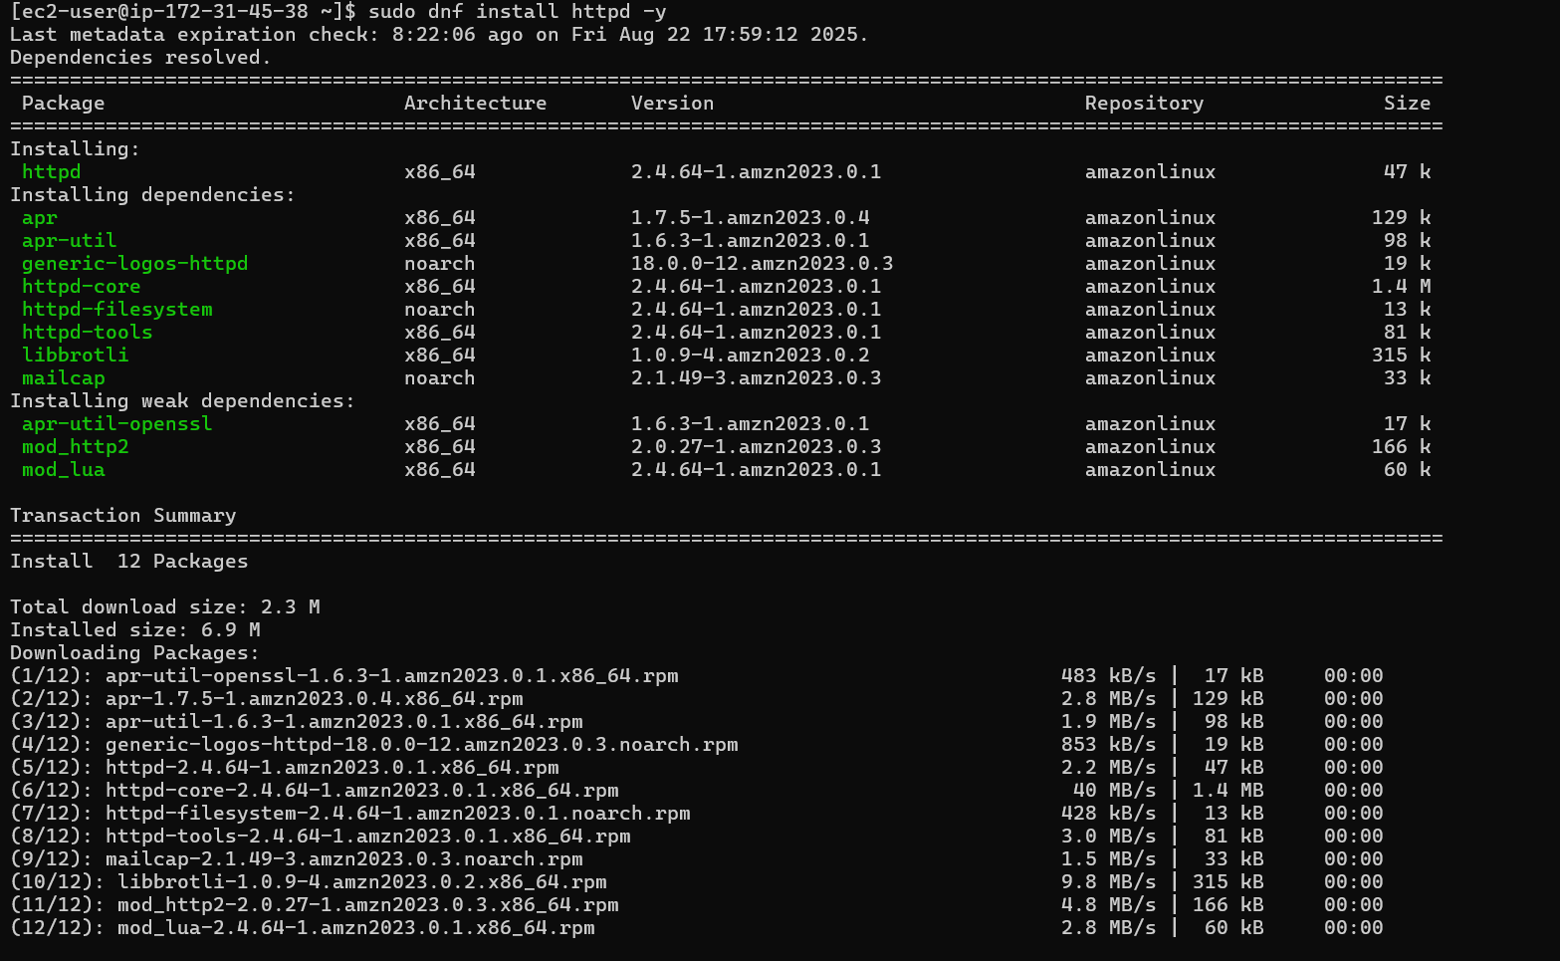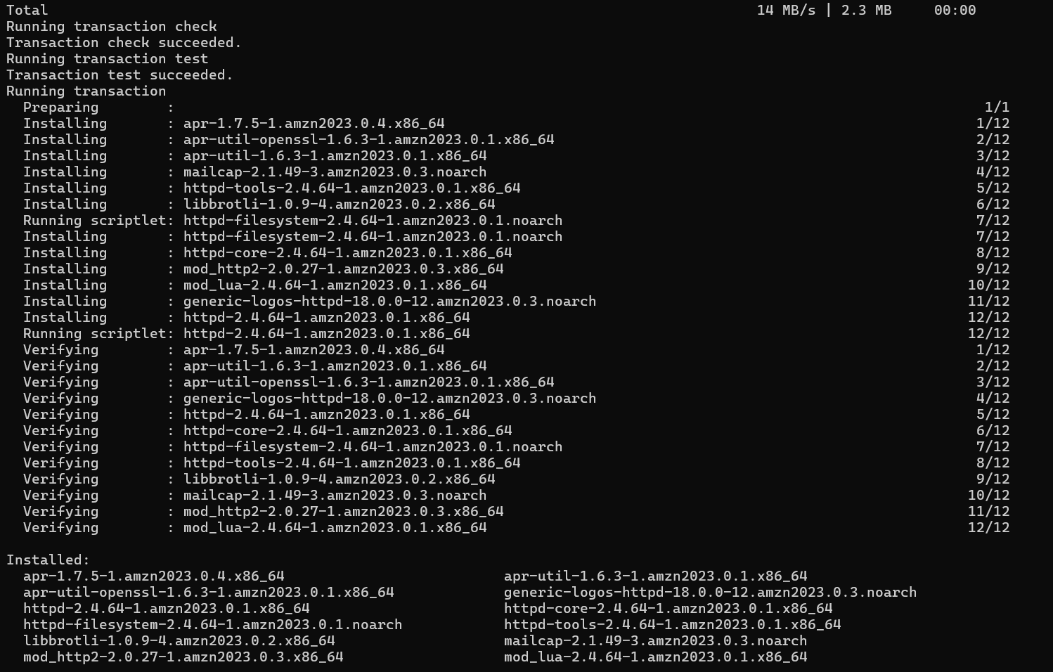

🔹 **Step 2: Start and Enable the Service**  Next, we started the httpd service and ensured it would automatically run after a reboot: *sudo systemctl start httpd /// sudo systemctl enable httpd* /// *sudo systemctl status httpd*. The status command confirmed that Apache was running properly.

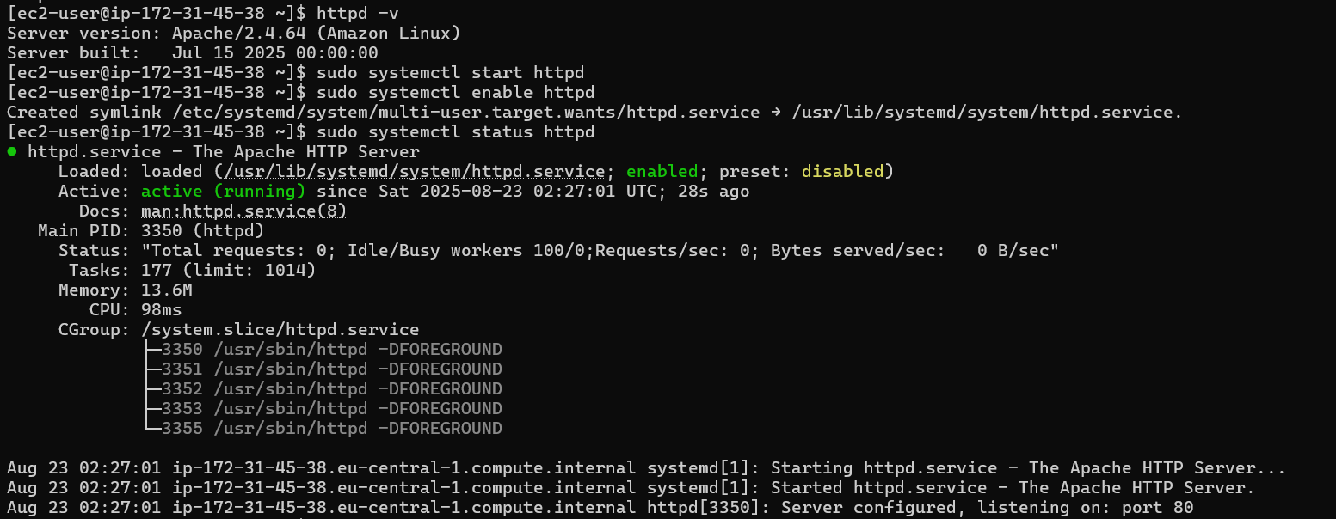

🔹 **Step 3: Create a Simple Webpage** We created a basic HTML file as the homepage by editing the default Apache directory:*sudo nano /var/www/html/index.html*. Inside this file, we wrote a simple HTML structure. For example:

<html>

<head><title>My First Webpage</title></head>

<body>

<h1>**Hello, this is Gabriela’s web page**</h1>

</body>

</html>

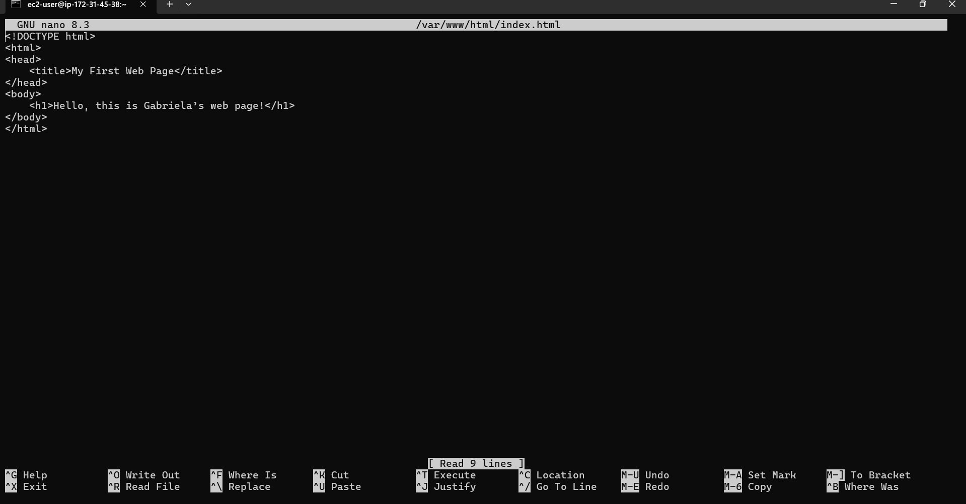

🔹 **Step 4: Adjust Permissions** To ensure Apache can serve the webpage without issues, we updated file permissions using chown and chmod. This step allows the web server to read the file correctly: *sudo chown -R apache:apache /var/www/html/index.html /// sudo chmod -R 755 /var/www/html/index.html*

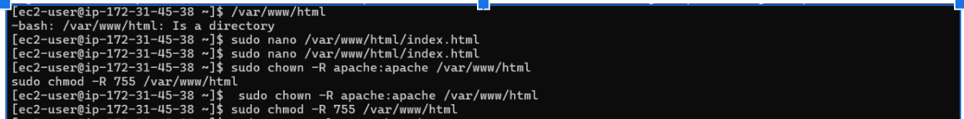

🔹 **Step 5: Restart Apache** After editing the file and updating permissions, we restarted and re-enabled the service to apply changes: *sudo systemctl start httpd /// sudo systemctl enable httpd* /// *sudo systemctl status http*

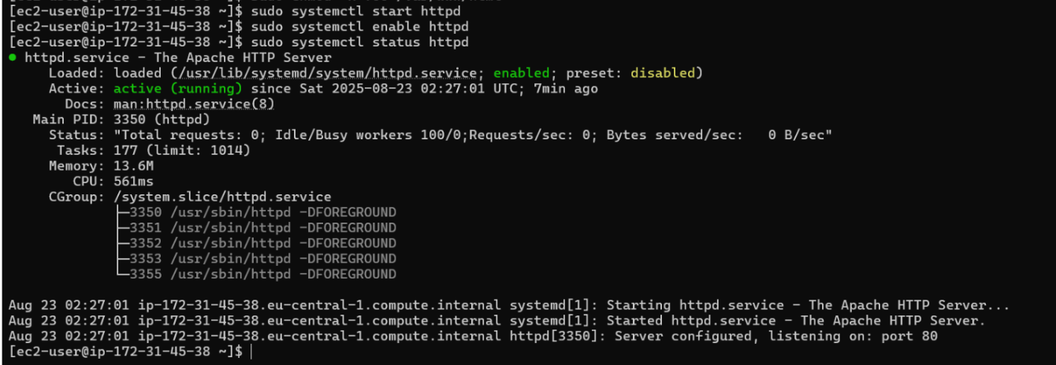

🔹 **Step 6: Access the Webpage** Finally, we opened a browser and visited the public IP address of our EC2 instance (created earlier from the AMI) to view the webpage:**Webpage URL:** <http://54.93.248.41/>. The browser displayed our test message **“Hello, this is Gabriela’s web page.”** Webpage: http://54.93.248.41/

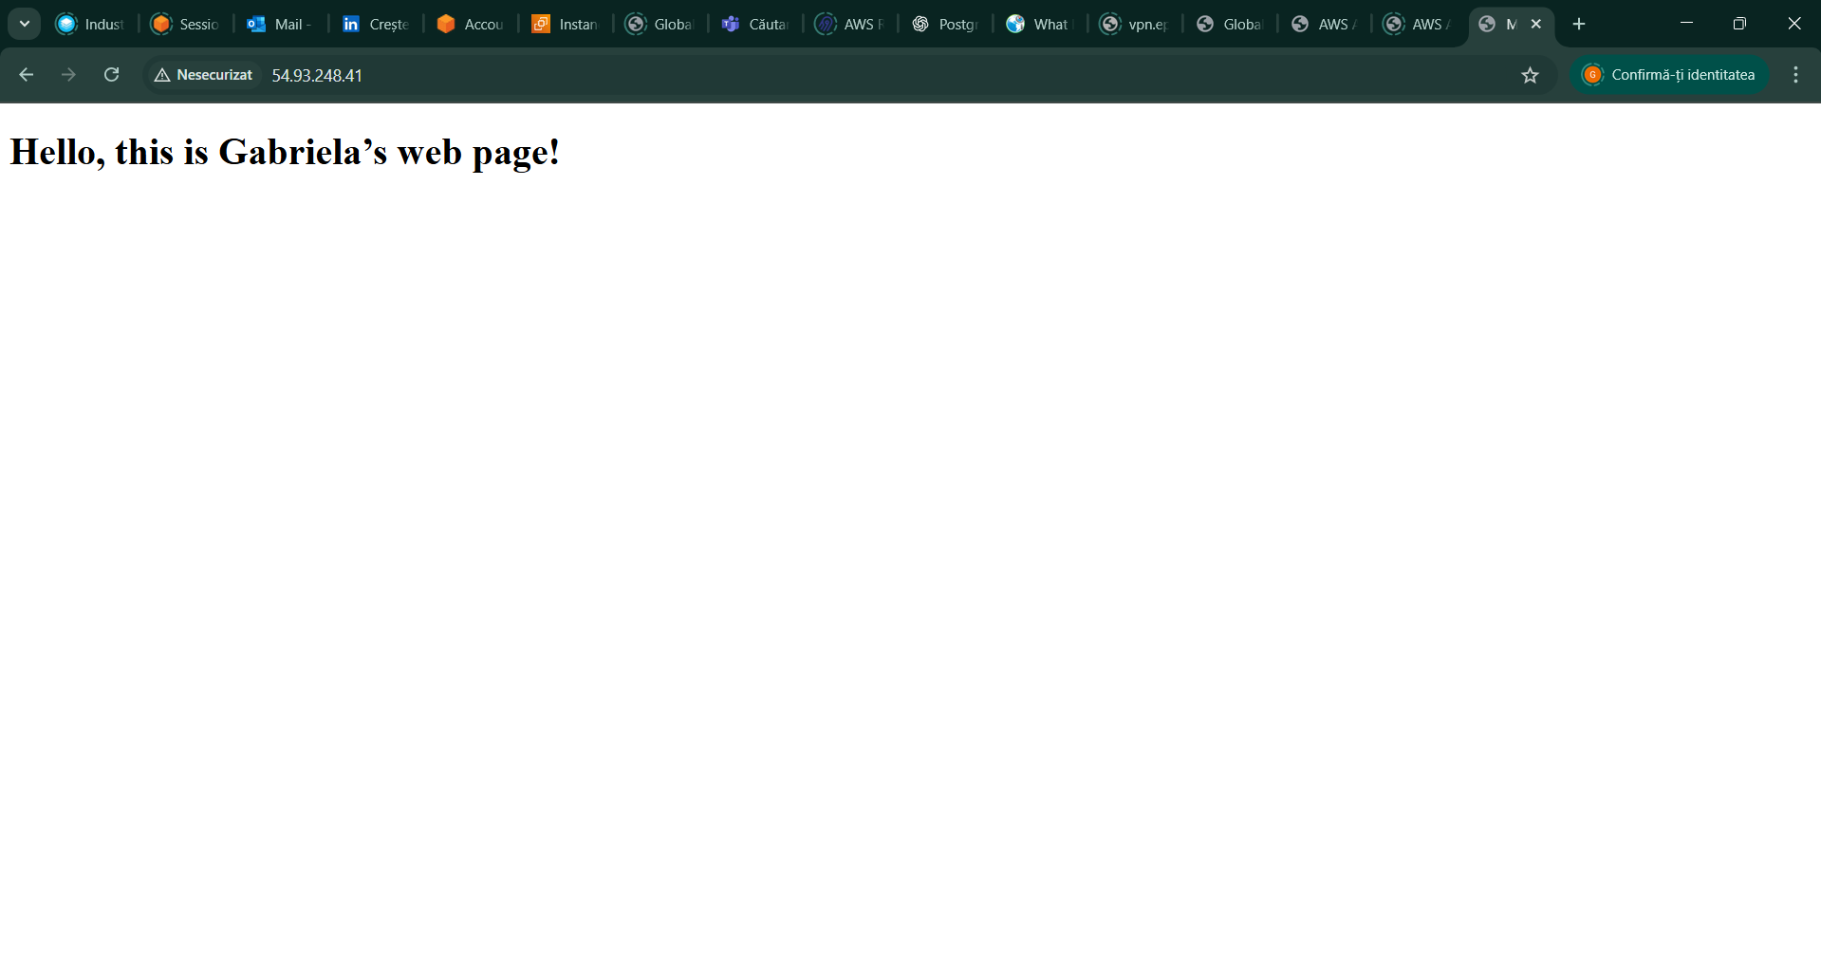

6. You will have the rights to create SNS notifications.

Create **Senseful** CloudWatch Alarm for any events exceeding your EC2 resources and create your own SNS queue, that will send the results to your email (you specify email when creating SNS). Appropriate screens to the Report.

🔹 **Step 1: Create an SNS Topic**  We started by creating an SNS (Simple Notification Service) topic that CloudWatch will use to send alerts. I chose **Standard** as the type (instead of FIFO), since ordering of messages isn’t critical for alarms.Then, I gave the topic a descriptive name: **EC2_gabriela_cretu_topic_alarm**.

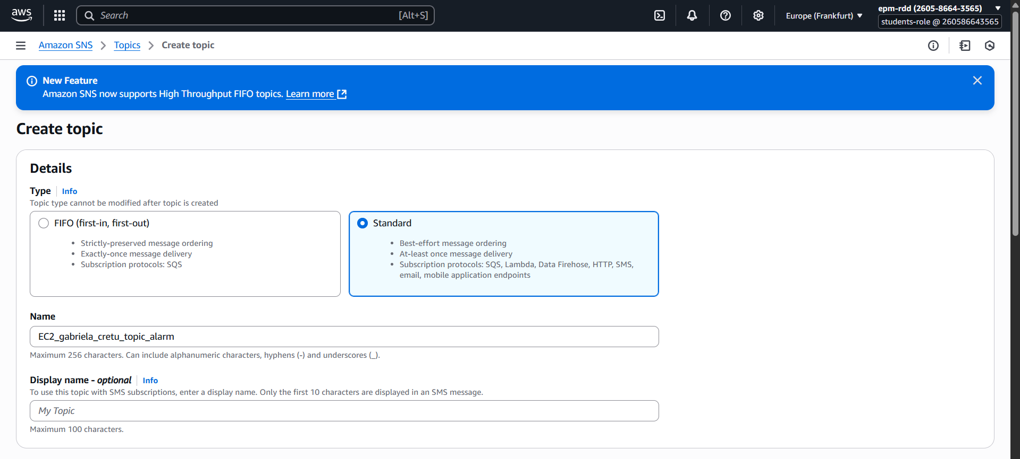

🔹 **Step 2: Create a Subscription**  Next, we created a subscription so that notifications from the topic would reach us by email.Selected the newly created topic and Chose **Protocol → Email**.  
Entered my **epam email address**. After that, I received a confirmation email and clicked the link to confirm the subscription.

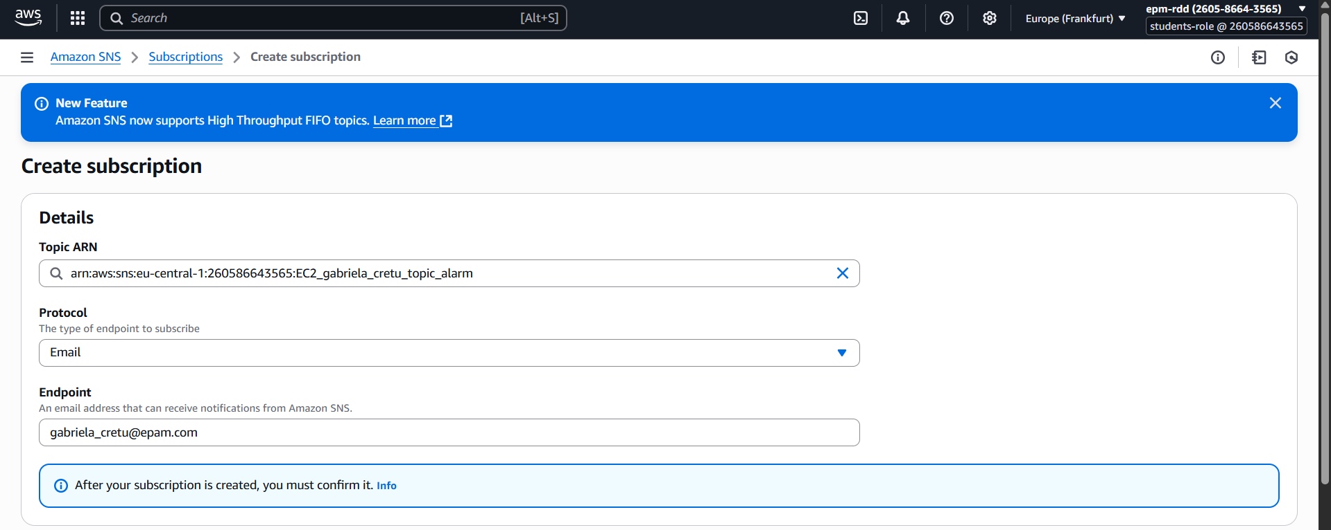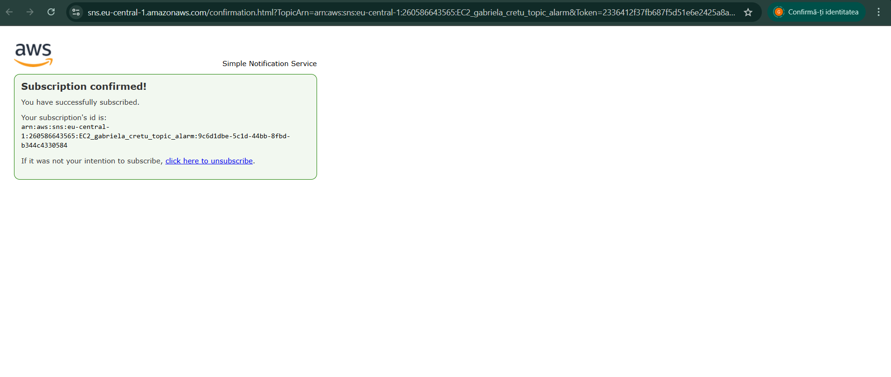

🔹 **Step 3: Create a CloudWatch Alarm** We navigated to **CloudWatch → Alarms → Create alarm**. Selected **EC2 metrics** → **Per-instance metrics** → **CPUUtilization** for our specific instance (i-02c4b1d1720c1c6ed). Defined the alarm condition: **CPUUtilization > 70% for 5 minutes**. For actions, selected **Send notification to the SNS topic (EC2_gabriela_cretu_topic_alarm)**. Chose **Do nothing** for missing data.  
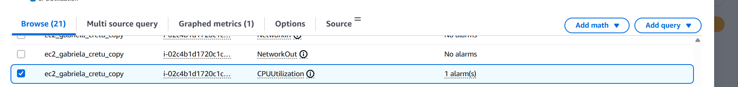

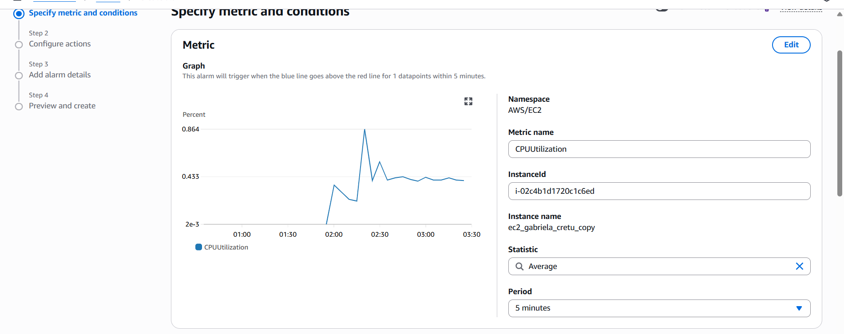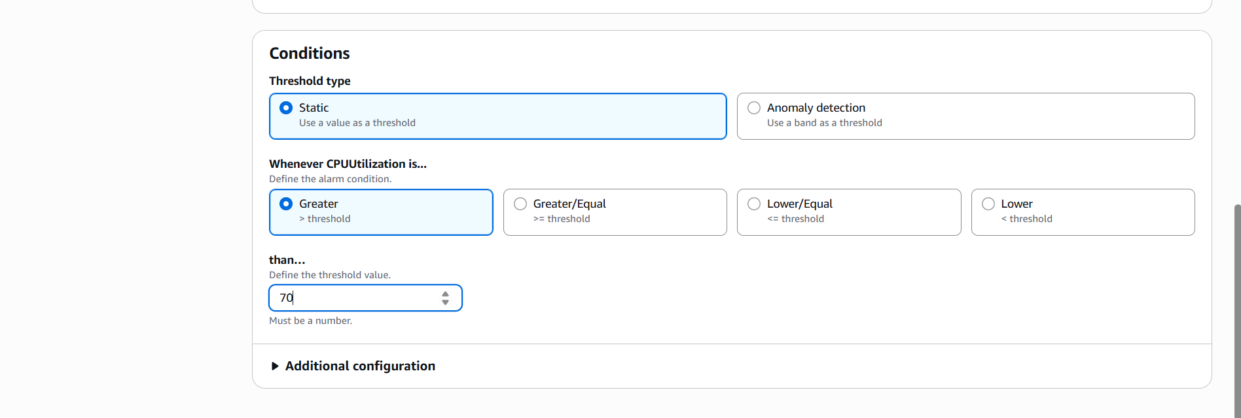

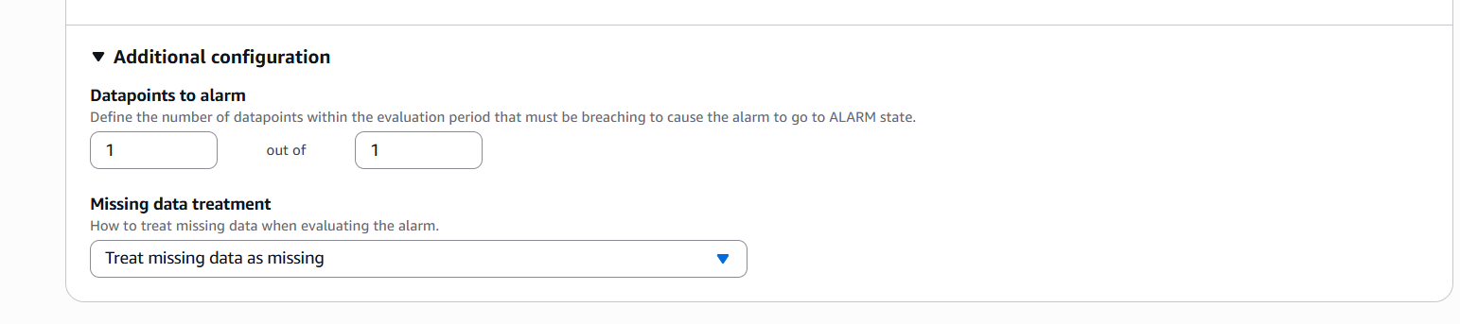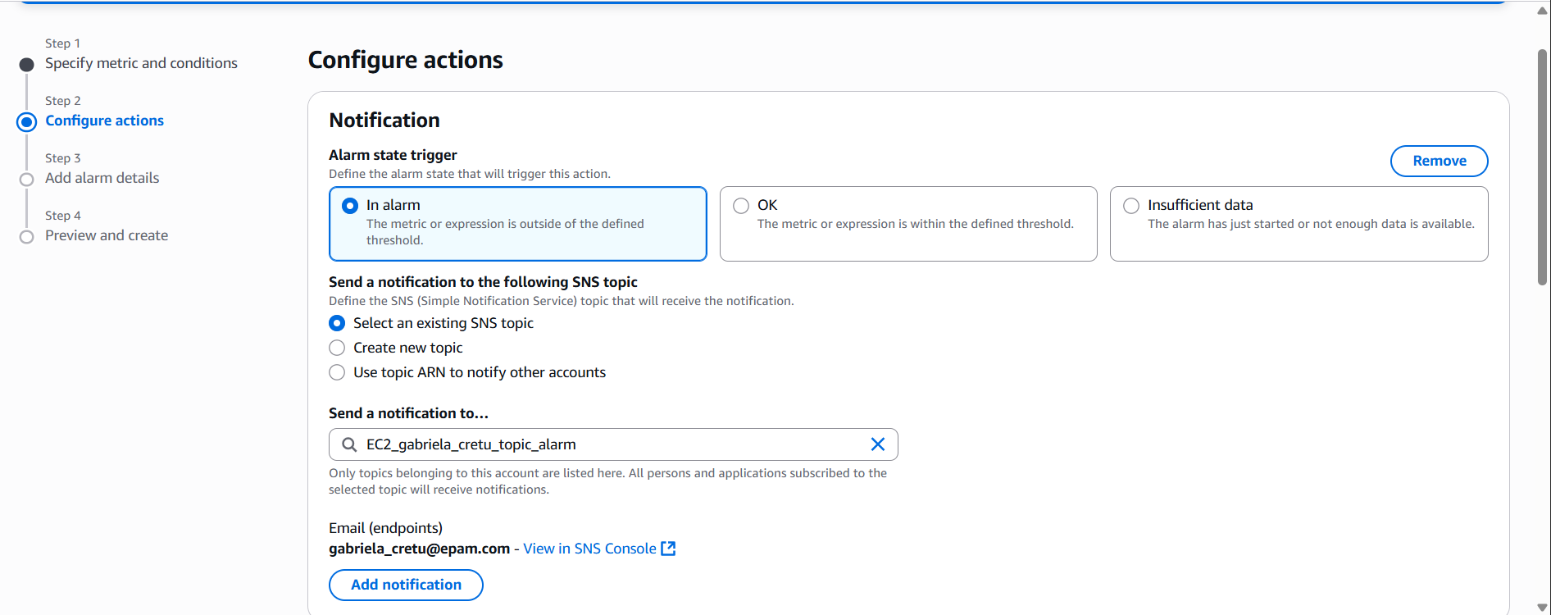

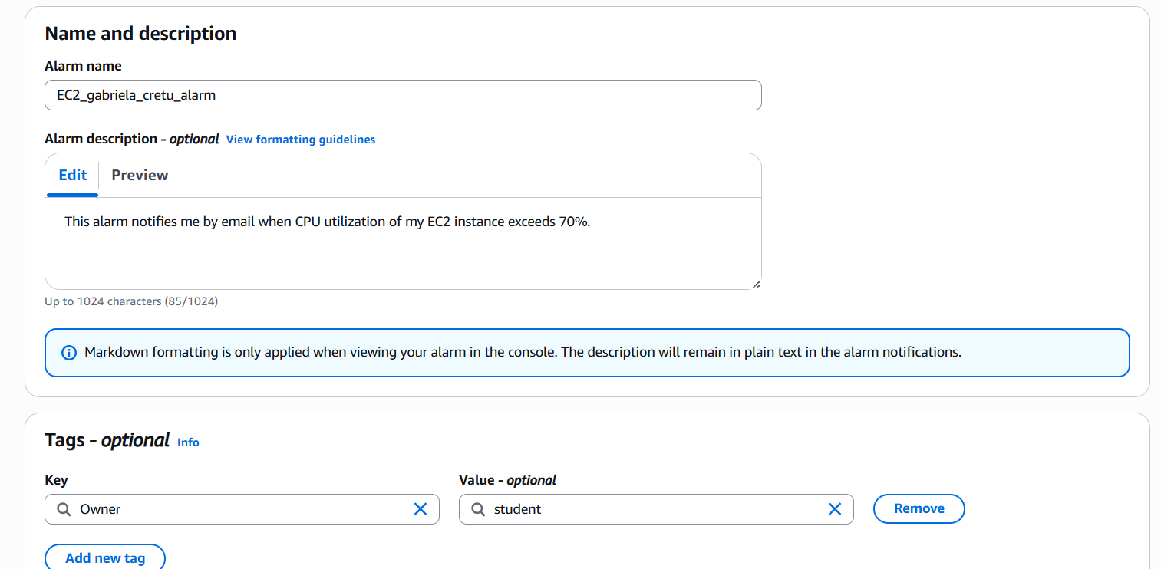

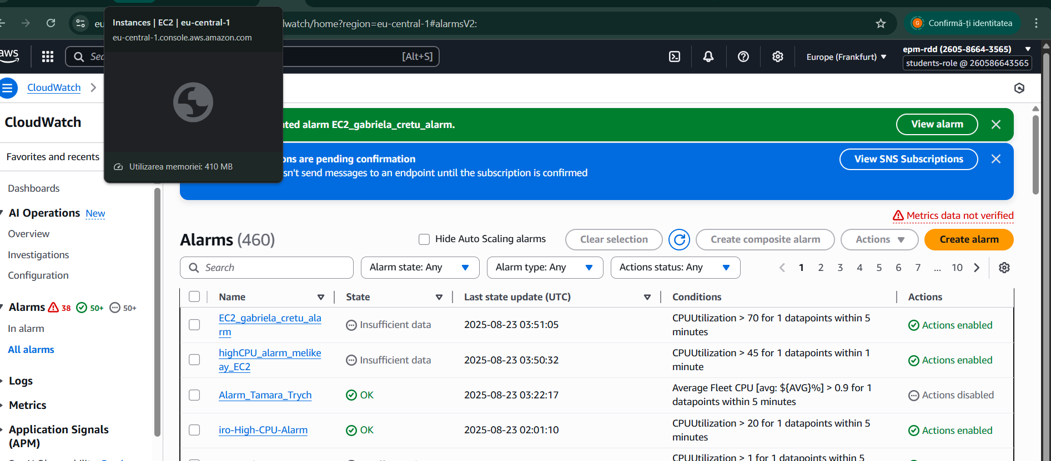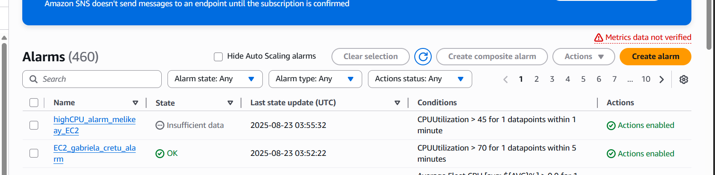

🔹 **Step 4: Test the Alarm** To test if the alarm works correctly, we simulated high CPU load:Installed the stress tool. Ran the stress test for 300 seconds on 2 CPUs: *stress --cpu 2 --timeout 300.* Shortly after, the alarm condition was triggered, and I received an email notification from CloudWatch as expected.

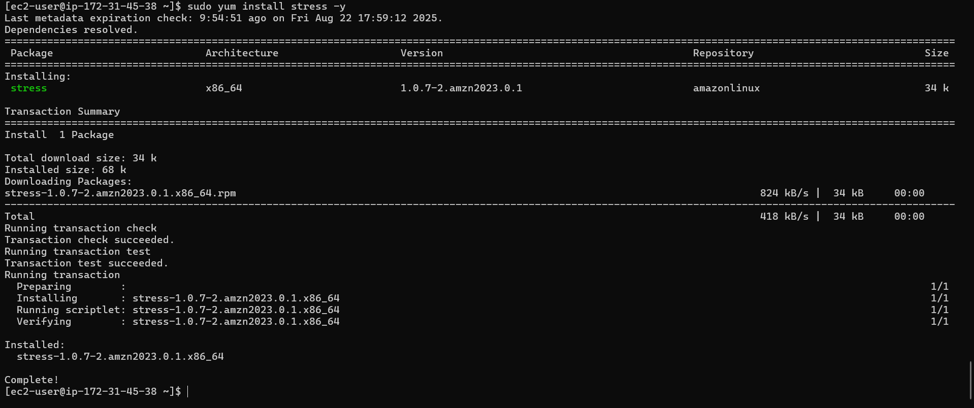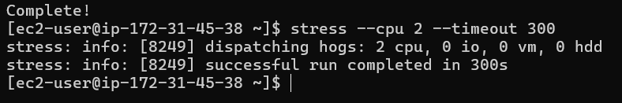

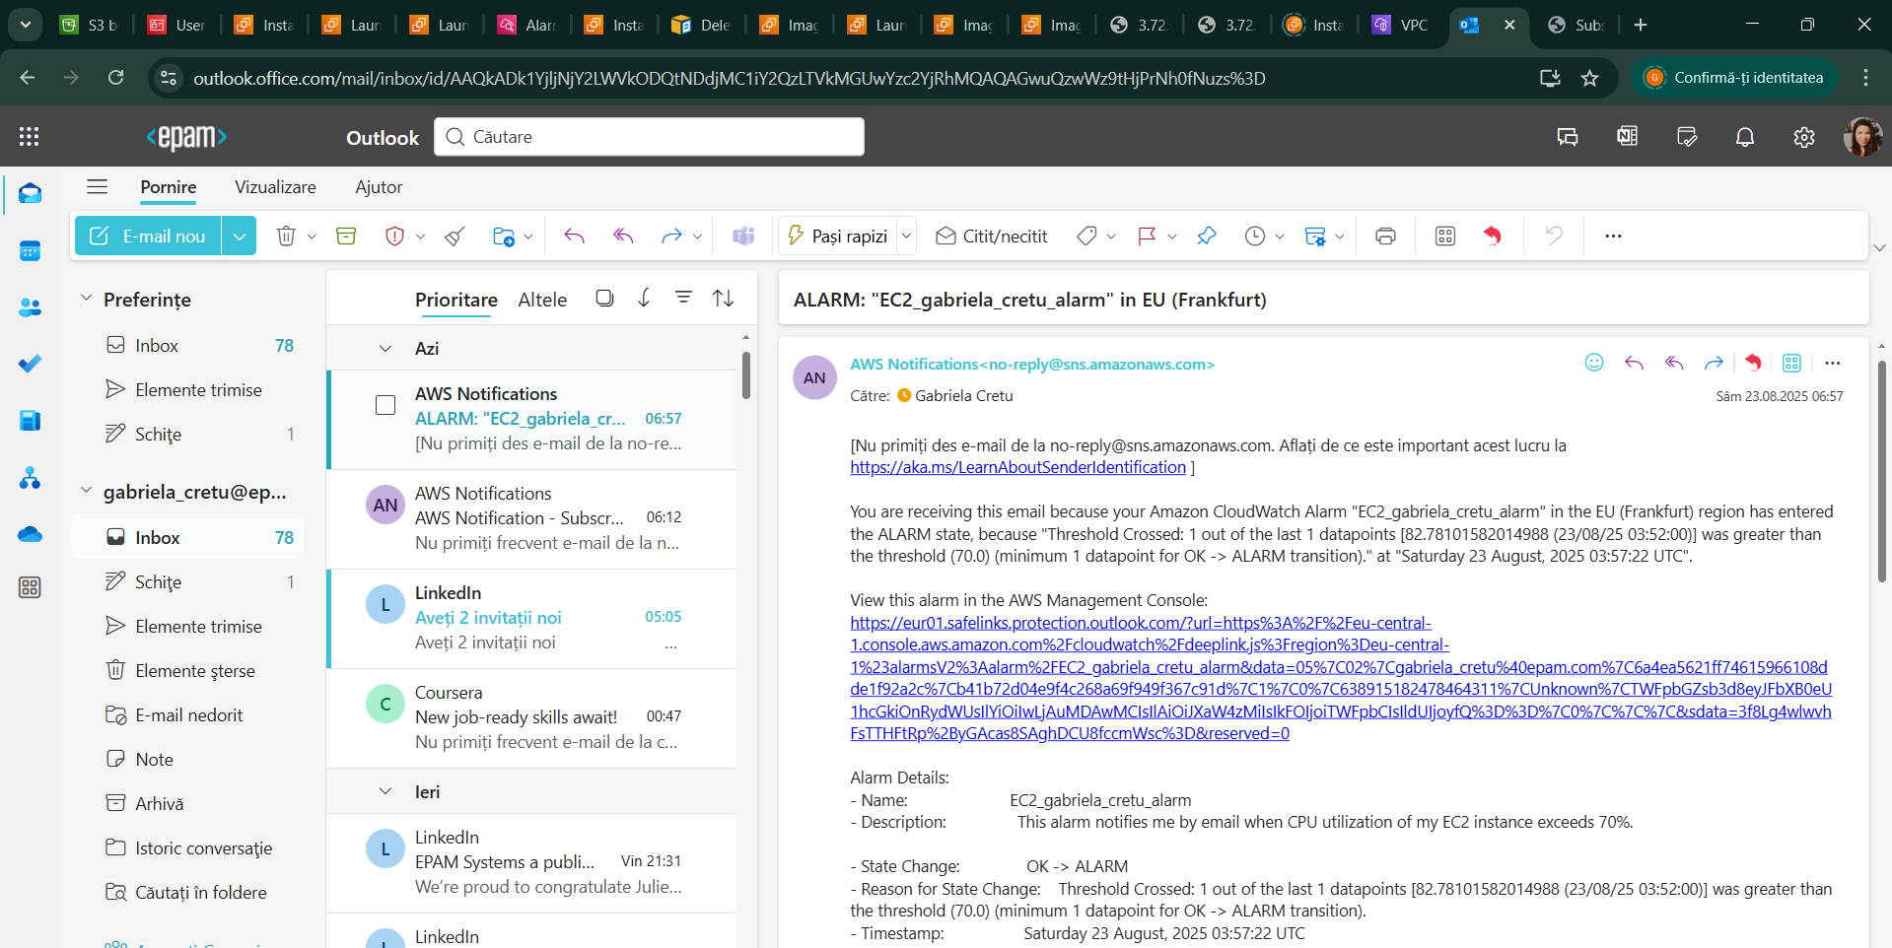

7. Try to create same EC2 virtual machine using a CloudFormation script. Save the script into your bucket and to the Report.

🔹 **Step 1: Prepare the CloudFormation Template** We opened the command prompt and created a new YAML template file by running: notepad ec2_copy_cf.yaml This opened a Notepad editor where we wrote the **CloudFormation script** to recreate our EC2 virtual machine. Before this step, we had exported the **JSON configuration file** of our existing EC2 instance. This provided all the necessary parameters (instance type, AMI ID, volumes, security groups, etc.) needed for the YAML script.



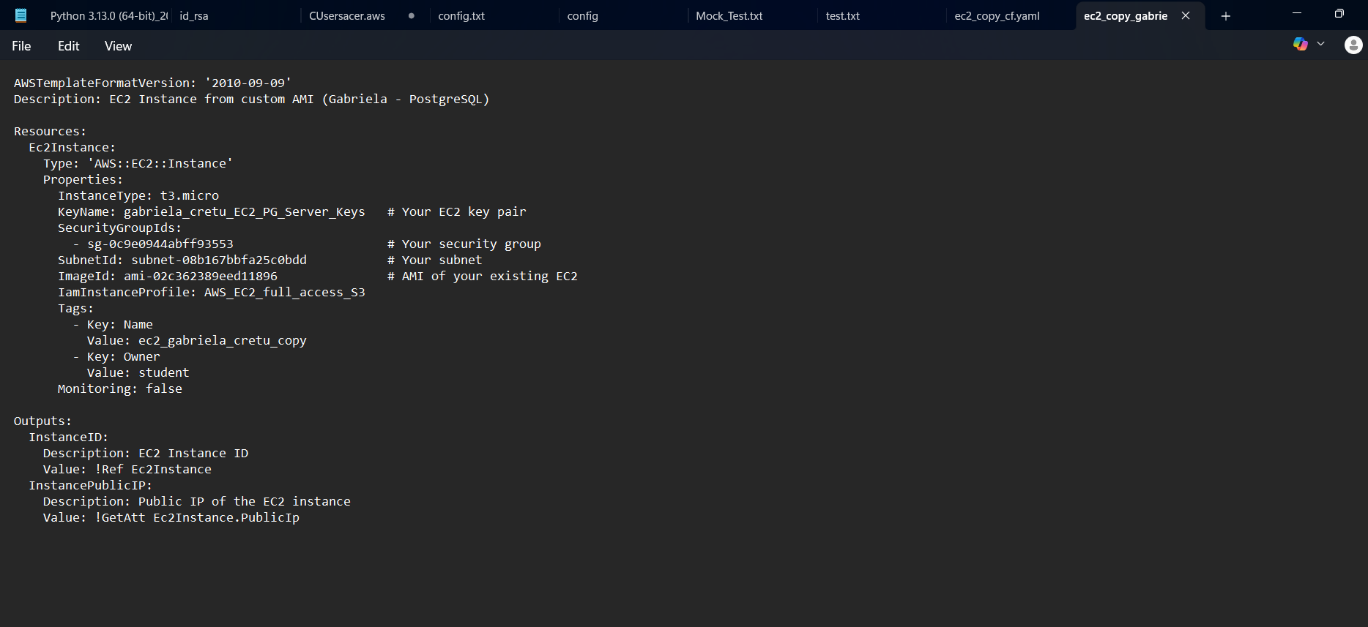

🔹 **Step 2: Save the Template** After completing the CloudFormation script in Notepad, we saved it as **ec2_copy_cf.yaml** and also threw it in our bucket. This file defines the infrastructure that CloudFormation will use to deploy the new EC2 instance.



🔹 **Step 3: Deploy the CloudFormation Stack** From the command prompt, we deployed the stack using the YAML file: aws cloudformation create-stack --stack-name ec2_copy_stack --template-body file://ec2_copy_cf.yaml

* --stack-name gave a specific name to the CloudFormation stack.
* --template-url pointed to the saved YAML file in our bucket.

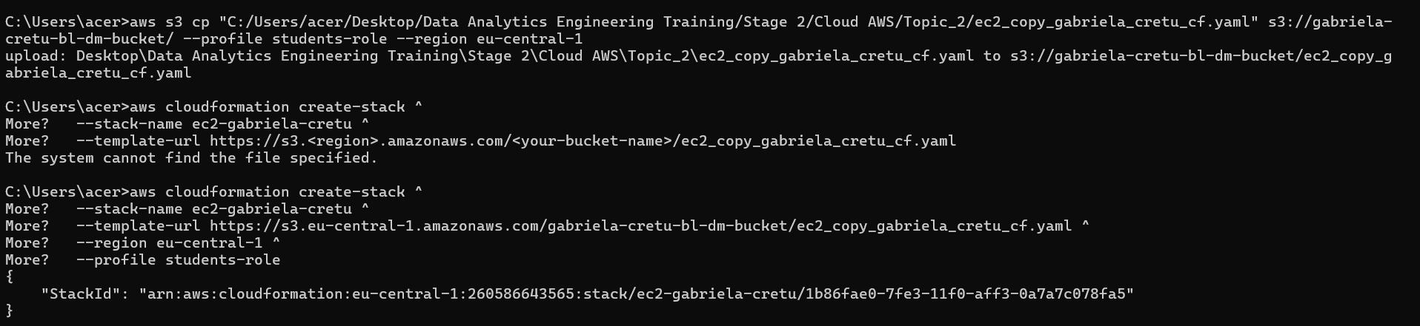

🔹 **Step 4: Verify the Instance** After a few minutes, CloudFormation successfully created a new EC2 instance that mirrored our original one. We verified in the **EC2 console** that the new instance appeared with the specified name and configuration.

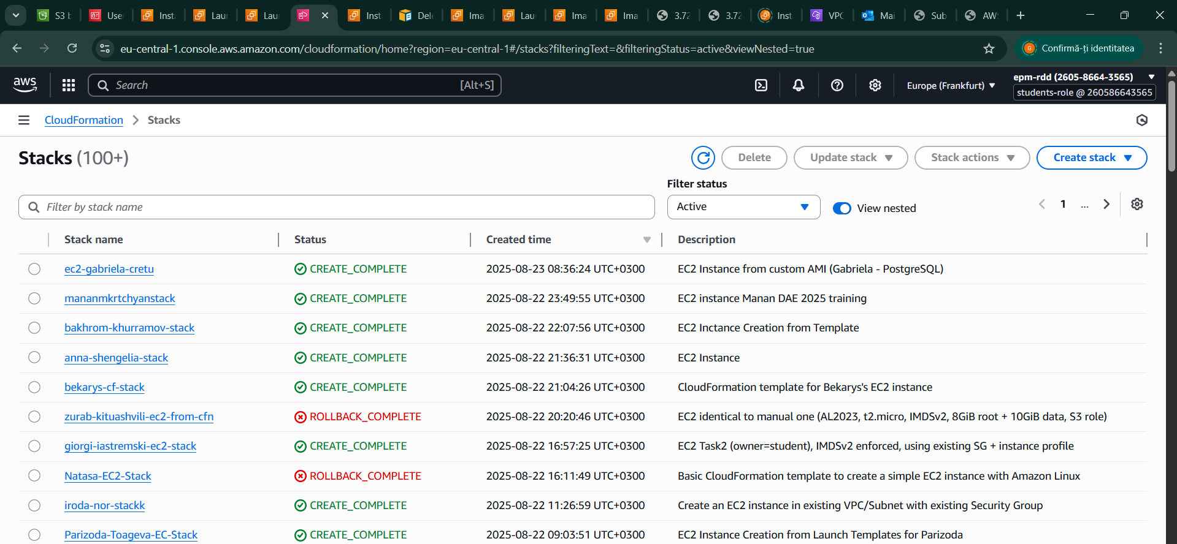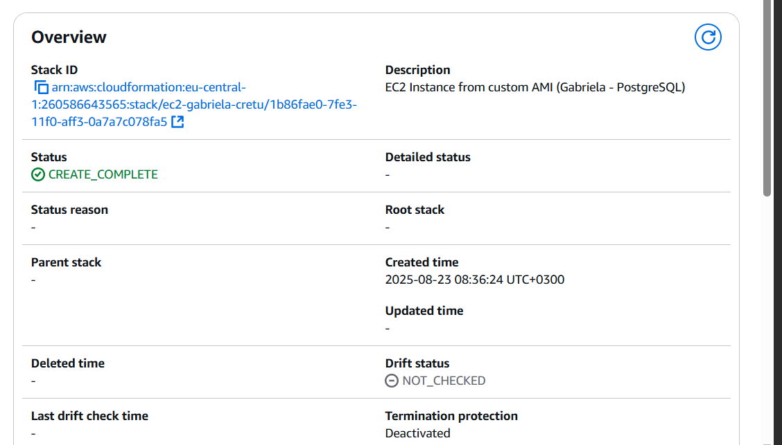

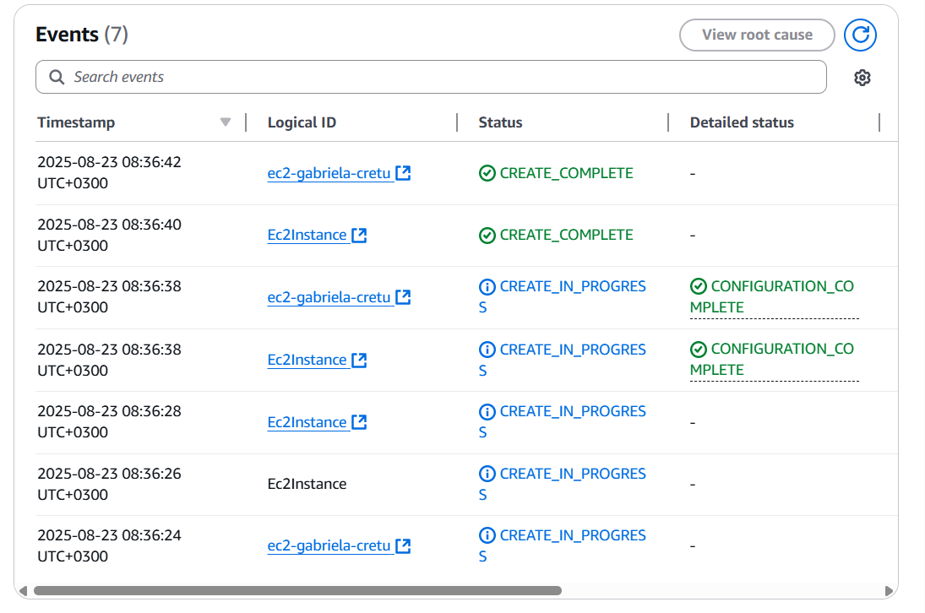

Here, we have the ip address:

